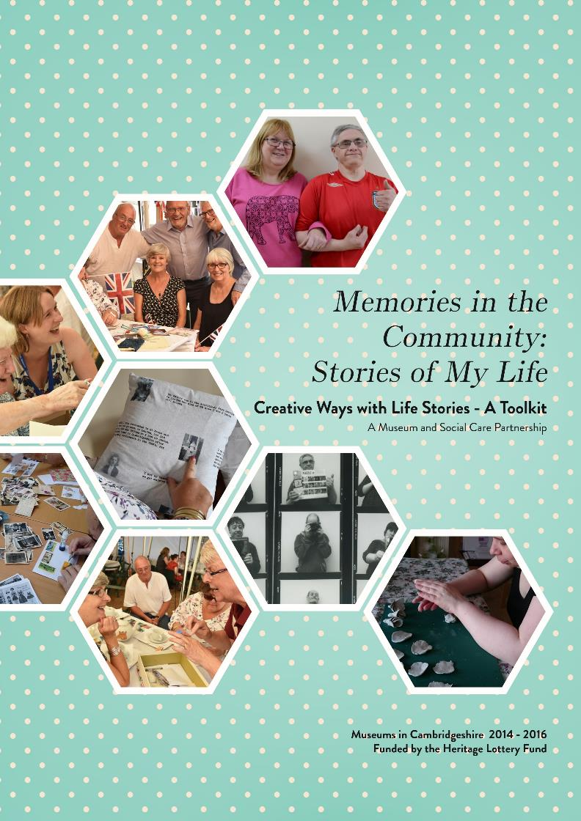
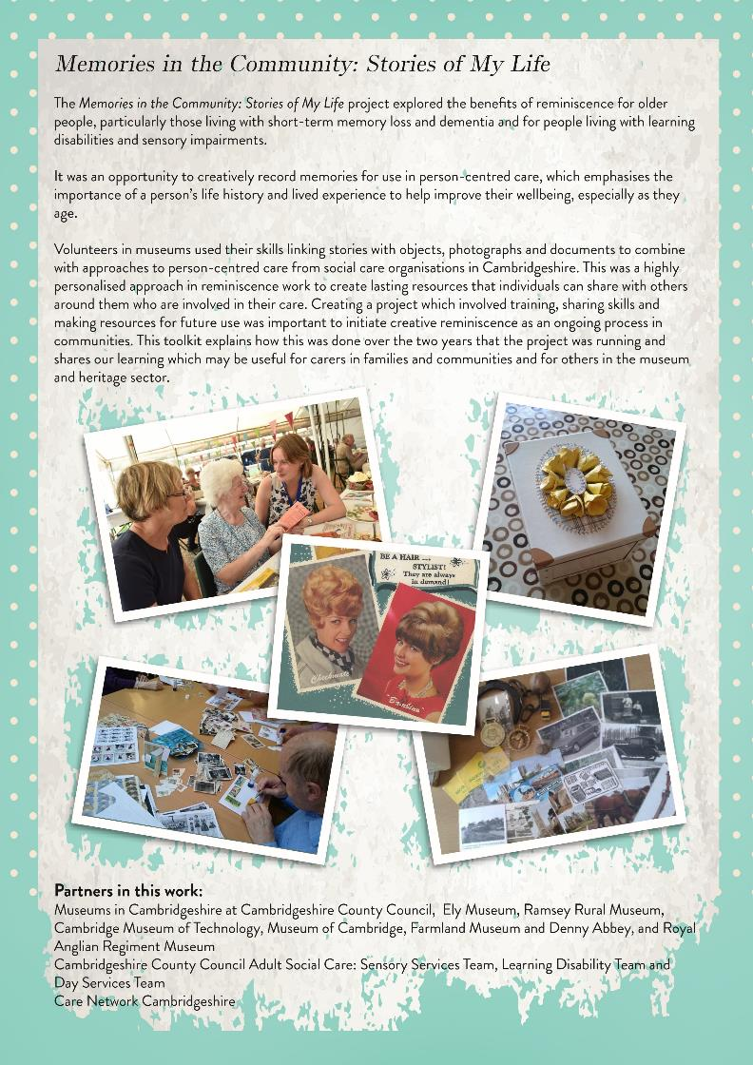
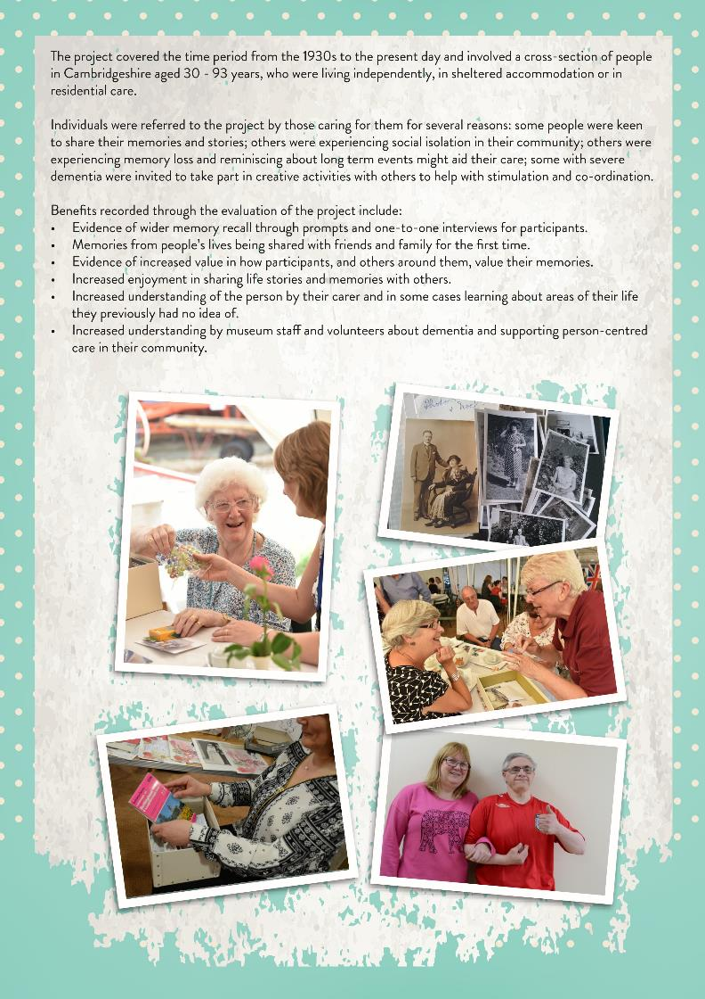

What We Did

Reminiscence Training
At the start of the project, 40 care and museum staff and volunteers took part in lively training workshops about memory and life story work. These were led by Julie Heathcote, Associate Reminiscence Trainer, Alzheimer’s Society and involved learning about how objects, photographs, smells and sounds affect people with memory issues and how reminiscence can be a life-affirming and fun activity for people later in life.
“It has reminded me of ways to talk to people to get them to talk about themselves and maintaining their value and self esteem.”

Life Story Interviews
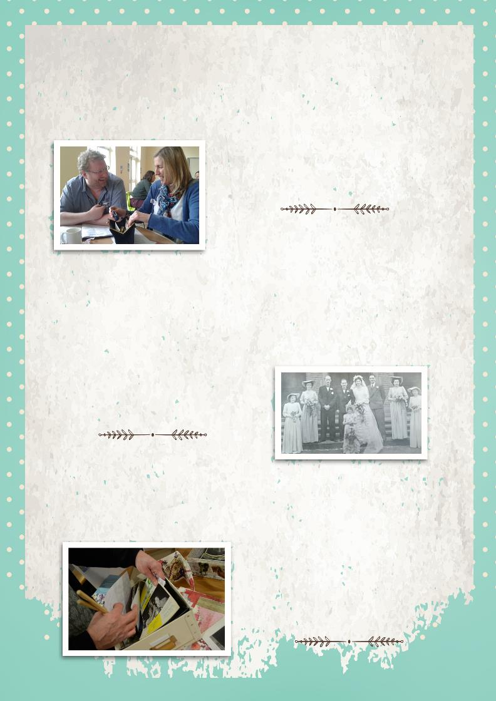
Following referrals from care organisations, care volunteers and/or staff met and reminisced with individuals as part of a life story interview. Some volunteers used photographs, objects and songs as prompts and recorded the information on a memory capture form. The interviews usually lasted 1 - 2 hours and involved care volunteers discussing topics from the person’s life with them at home or with care staff in their residential care home. Some people chose to do these over several sessions and often the care volunteers were known to the person through other care they had provided to them.
“I’ve enjoyed being able to share my memories with
someone who is interested.”

Personalised Memory Boxes
Using these forms and working with the care staff and volunteers who carried out the interviews, museum volunteers researched and gathered together objects, photographs and documents related to the specific memories and created a box for each person. There were 21 volunteers who took part in the process, either carrying out life story interviews or creating boxes across Cambridgeshire for 32 individuals.
“I was a radio operator during the war and could tell you some stories. Once I
started talking it all came tumbling out.
I enjoyed talking to others about what
I had done using the box and I think I might need a bigger box!”

Creative Workshops: Collage and Textiles
The creative workshops for adults with learning disabilities and sensory impairment were stimulating and fun. Artist Karen Jinks, led workshops where people created collage cards and pictures using original photographs, cigarette cards, postcards and fabric. In other settings she worked with groups who chose images, fabric, and original writing to create a one-off patchwork piece. Both processes involved people sharing and talking about the past and what they were doing as part of the process and everyone kept their artwork.
“There was engagement in the moment and
objects were useful to
prompt memories from the past.”

Photography
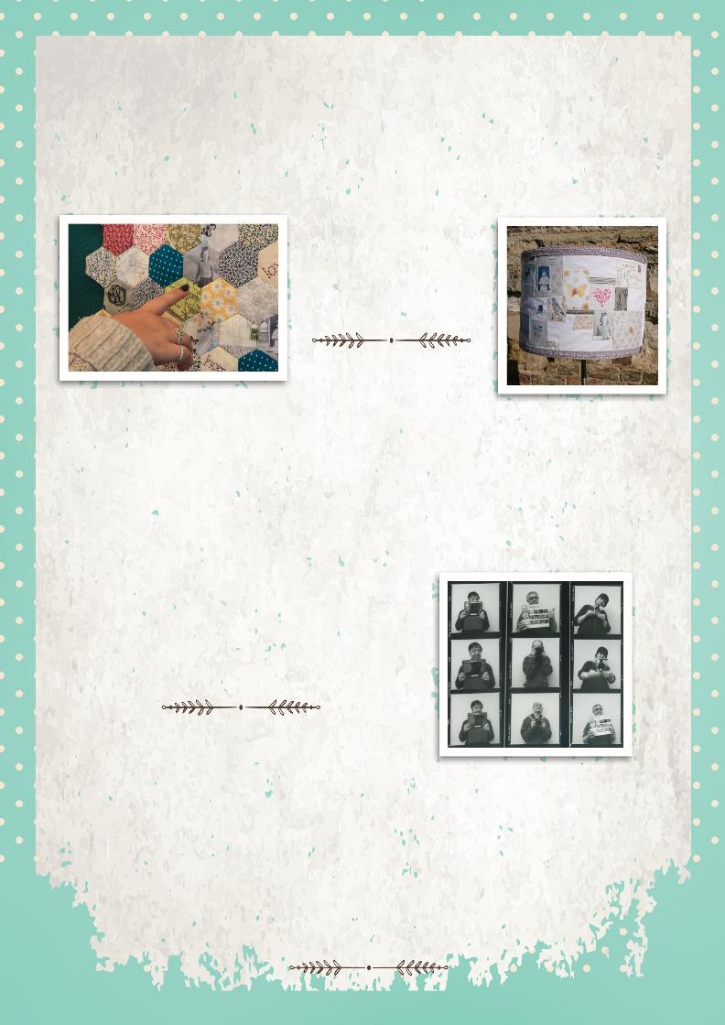
Photographer Kay Goodridge explored self portraits with a group of younger people with learning disabilities using an iPad, Smartphone, and Polaroid and Bronica cameras. Working individually and as a group with their key worker, people built up a series of photographs of themselves, sometimes with a chosen object of significance, or of places which have meant something to them and their families. Over time, each person chose images they wanted to add to a unique workbook and added notes in their own words. These workbooks belong to the participants and have been shown to each other, friends, family and other carers. The photographs formed a slideshow and were presented at their care setting and at a celebration Tea Party at the end of the project. Following on from this, the group and other people at the community centre take part in regular photography art sessions in house, which also record new memories.
“Andrew has got the most out of it - at every opportunity he wants to take pictures. To get
him taking part is amazing - he has loved
choosing and sticking his photos in the workbook and showing everyone.”

Touring Exhibition and Sharing Events
These examples of creative reminiscence were incorporated into an exhibition which toured Cambridgeshire museums and community settings, raising awareness and support for memory work. The exhibition was specifically designed to be interactive and included quotes and voices of people reminiscing. A living room setting was created with an audio armchair playing reminiscences, quotes were designed onto cushions and curtains, and sample memory boxes were available to handle. Venues added their own material to it, and arranged sharing events in their community based around the exhibition, such as a carers’ open day and memory box-making workshops.
“A really enjoyable day that showed me how important memories are and in particular being able to share them.”

Creative Reminiscence - A Toolkit

Personalised Memory Boxes
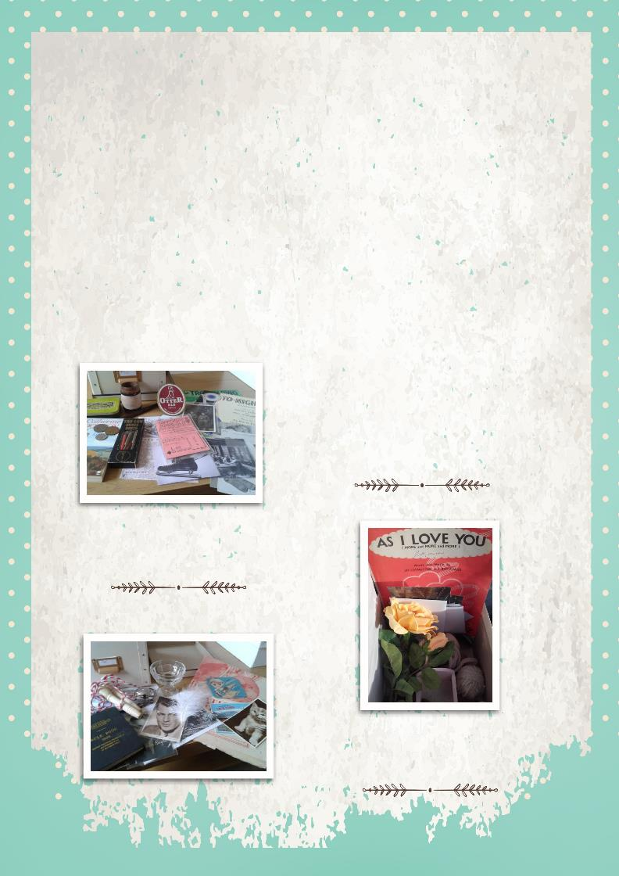
Volunteers who interviewed people in their community explored where people were born and grew up, their memories of school, subjects they did, particular teachers they had, funny stories about tricks, games, songs from childhood, particular memories about birthdays, celebrations, weddings or holidays. Progressing through life stages such as working life, relationships, moving house and interests meant that this was a very personal record. In many cases, interviewers were also finding out about the effects of significant national and local events such as war, unemployment, improvements in housing and changes in popular culture through the eyes of people sharing their own experiences on a personal level. Music, dance, cinema, books, fashion and hobbies were areas where people recalled individual tastes and key memories.
During this process, it is important to follow the pace of the interviewee, where one memory leads to others and to ask open questions such as ‘Can you describe...?’ or ‘What was it like to...? Often reminiscing in this way can be great fun, sometimes intense, sometimes sad and upsetting as memories are connected with a range of emotions. It is important to listen to the mood of the interviewee as they are talking and only explore what the interviewee wishes to talk about at the time. Some volunteers were keen to digitally record the interviews so that these could be added to the memory box for others to hear. This can also be helpful for carers if individuals experience problems communicating later on in their life.
“Eileen has been a strong figure in the
village and worked hard to improve
things. She is taking her box with her to various drop-ins and sharing with other people. I think it is good for her to talk
and keep her confidence but also I think she has a lot to be proud of.”
“I wrote to my friend about it and suggested they might do something similar and make it into a social evening.”
“I have used this with my daughter and my grandson.”

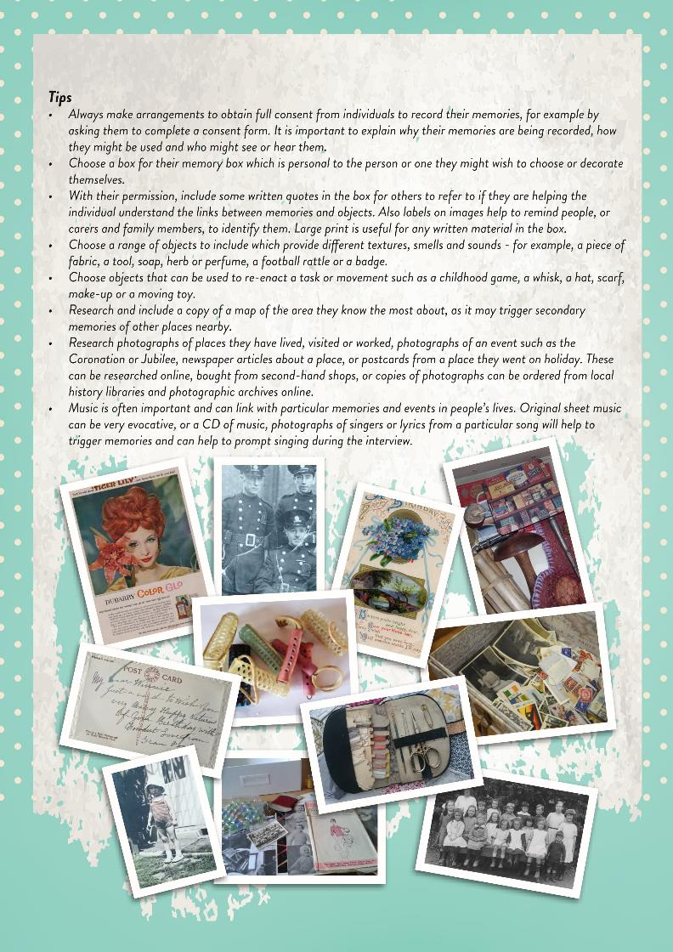
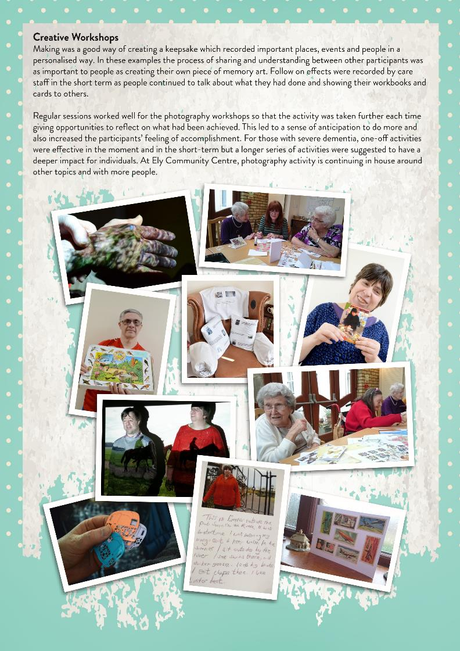

Tips
- Plan in time to understand a particular setting if working with people in residential care, meeting with key workers, learning the daily routines of individuals and to work out the depth and length of a workshop. Karen, the artist facilitating the group work with volunteers and key workers, planned where activities would take place, for how long and what stimulus would work for different individuals.
- Levels of engagement will be very different for each individual and so consider one activity which can offer different choices and techniques to try as part of it. Also invite people to bring their own material with them, pictures, postcards, and mementoes for inclusion or sharing.
- Working with individuals, particular memories or symbols were identified and designs were created from this. For example, one participant Sarah chose a yellow rose as symbolic of a place she loved and chose to recreate her design to decorate her memory box.
- Encourage ways for people to capture their memories in their own words by writing them as part of the artwork or alongside or having someone else record it if they are not able to.

Sharing Events
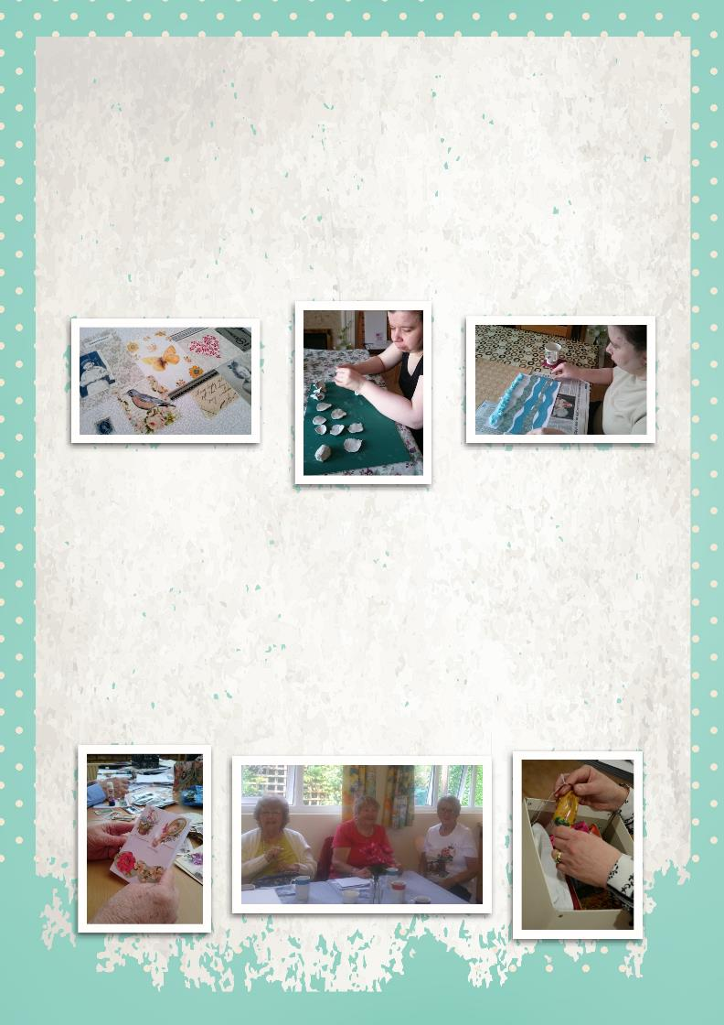
Planning sharing events was an important part of this project and brought together people to share their lives. It gives significance to their work and their lived experience. We identified coffee mornings in community cafes and shared communal spaces in sheltered accommodation, drop-in events at museums, and a larger scale Tea Party held at Ramsey Rural Museum for everyone involved in the project. Family members were invited along, other people in the local communities came to the drop-ins and coffee mornings and this gave people more opportunities to tell people about themselves and share their stories.
Museums are well-placed to do this for groups and individuals in their local area, by hosting events and displaying life stories for people in the locality for all ages to share. This can often lead to other connections and activities which participants can choose to take up. For example, Care Network volunteers are now arranging to create memory boxes as a community group in one Cambridgeshire village following this project.

Working Together

A Community Approach
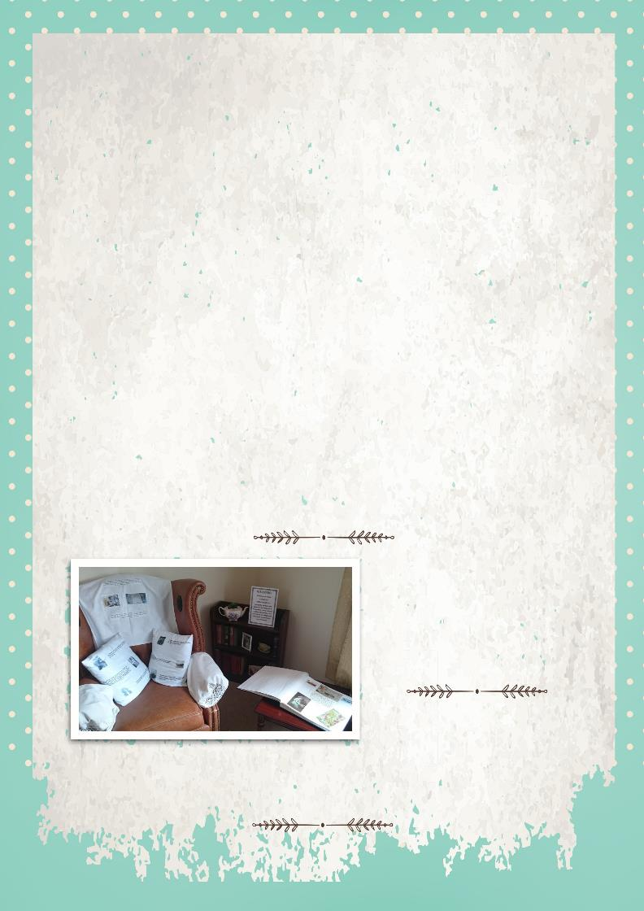
Memories in the Community: Stories of My Life has brought different sectors together in Cambridgeshire for the first time and shown how important a network of people are around a person needing care. This was a community approach to supporting person-centred care. Museums learned more about the needs of people in their community and how they can provide knowledge, material culture and hands-on experiences to support creative reminiscence resources. Care staff and families have had positive experiences of creative reminiscence methods which is enabling the activities to continue and reach more people.
In working together we learned:
- Having an event for carers and museum staff and volunteers at the start of the project is important to learn more about each other’s sector before the project begins.
- Care settings have daily and hourly changes as well as particular routines they use - keeping regular contact helps to learn when the best time is to arrange activities and also about expectations of individuals with different circumstances. Flexibility is key!
- Volunteers taking part are committed to their local area and to working on projects which support people in their own community. They saw the benefits for the local community of helping individuals share their memories with others living nearby.
- Some participants in this project, now living in Cambridgeshire, also lived in other parts of the country and abroad during their lives. Some felt their roots were elsewhere and having tangible reminders of places that had been significant in their lives has helped to keep important links associated with them. This has also helped to communicate to others in their new location more about their culture and previous lifestyles.
- It is important to create an opportunity to come together at the end of the project to see what can be learned and developed further as well as recognising volunteers for their work and commitment.
- Always allow more time than planned!
“I didn’t realise how important objects and photographs were... they hold so many memories but useful to have to touch and they often led us on another path of memories.”
“Learning more about what museums do and have has been useful to see
possibilities for visits and other work in the future.”
“This project has given me more insight into the work of Care
Network and also the community centre’s work. This has helped me see ways we can link with care groups in our area.”
