

Pinning on Small Objects

Shopping List

Masking Tape
Sharp/Soft Pencil
Ruler
Surgical Gloves
Clippers
Small Pointed Pliers
Hammer
Insect Pins – 0.1 to 0.7
Polythene Tubing
Safety Goggles
Pot for Sharps
Dremel (for use with hard MDF)
Drill bits – 0.3mm to 1mm

- Stick some masking tape onto the display board where you want to pin the object on.

- Making sure you are wearing gloves place the object on the board in the position you want it to be displayed.

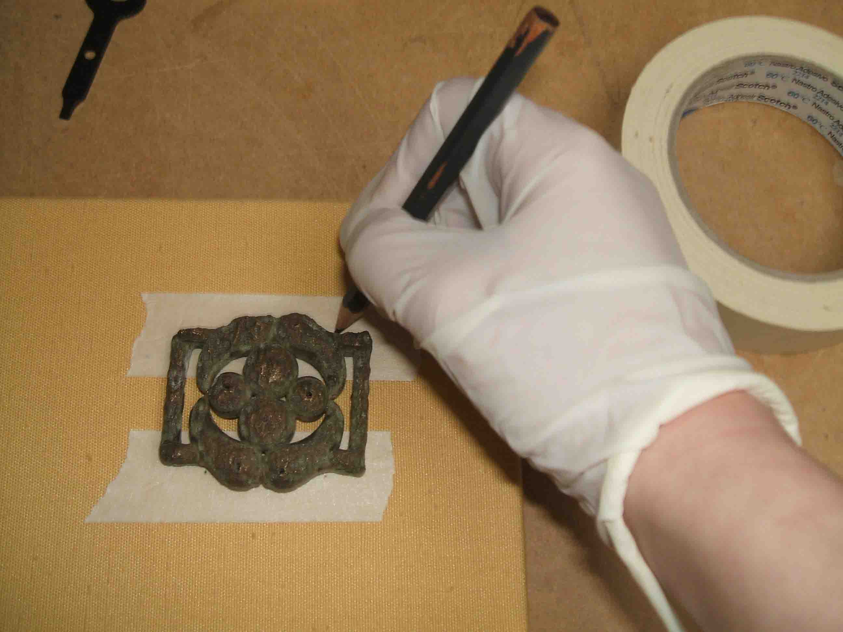
- Using a pencil draw dots on the masking tape where the pins are to go. The pins will need to support the object when the board is held at an angle or vertical. Make sure you do not touch the object with the pencil.
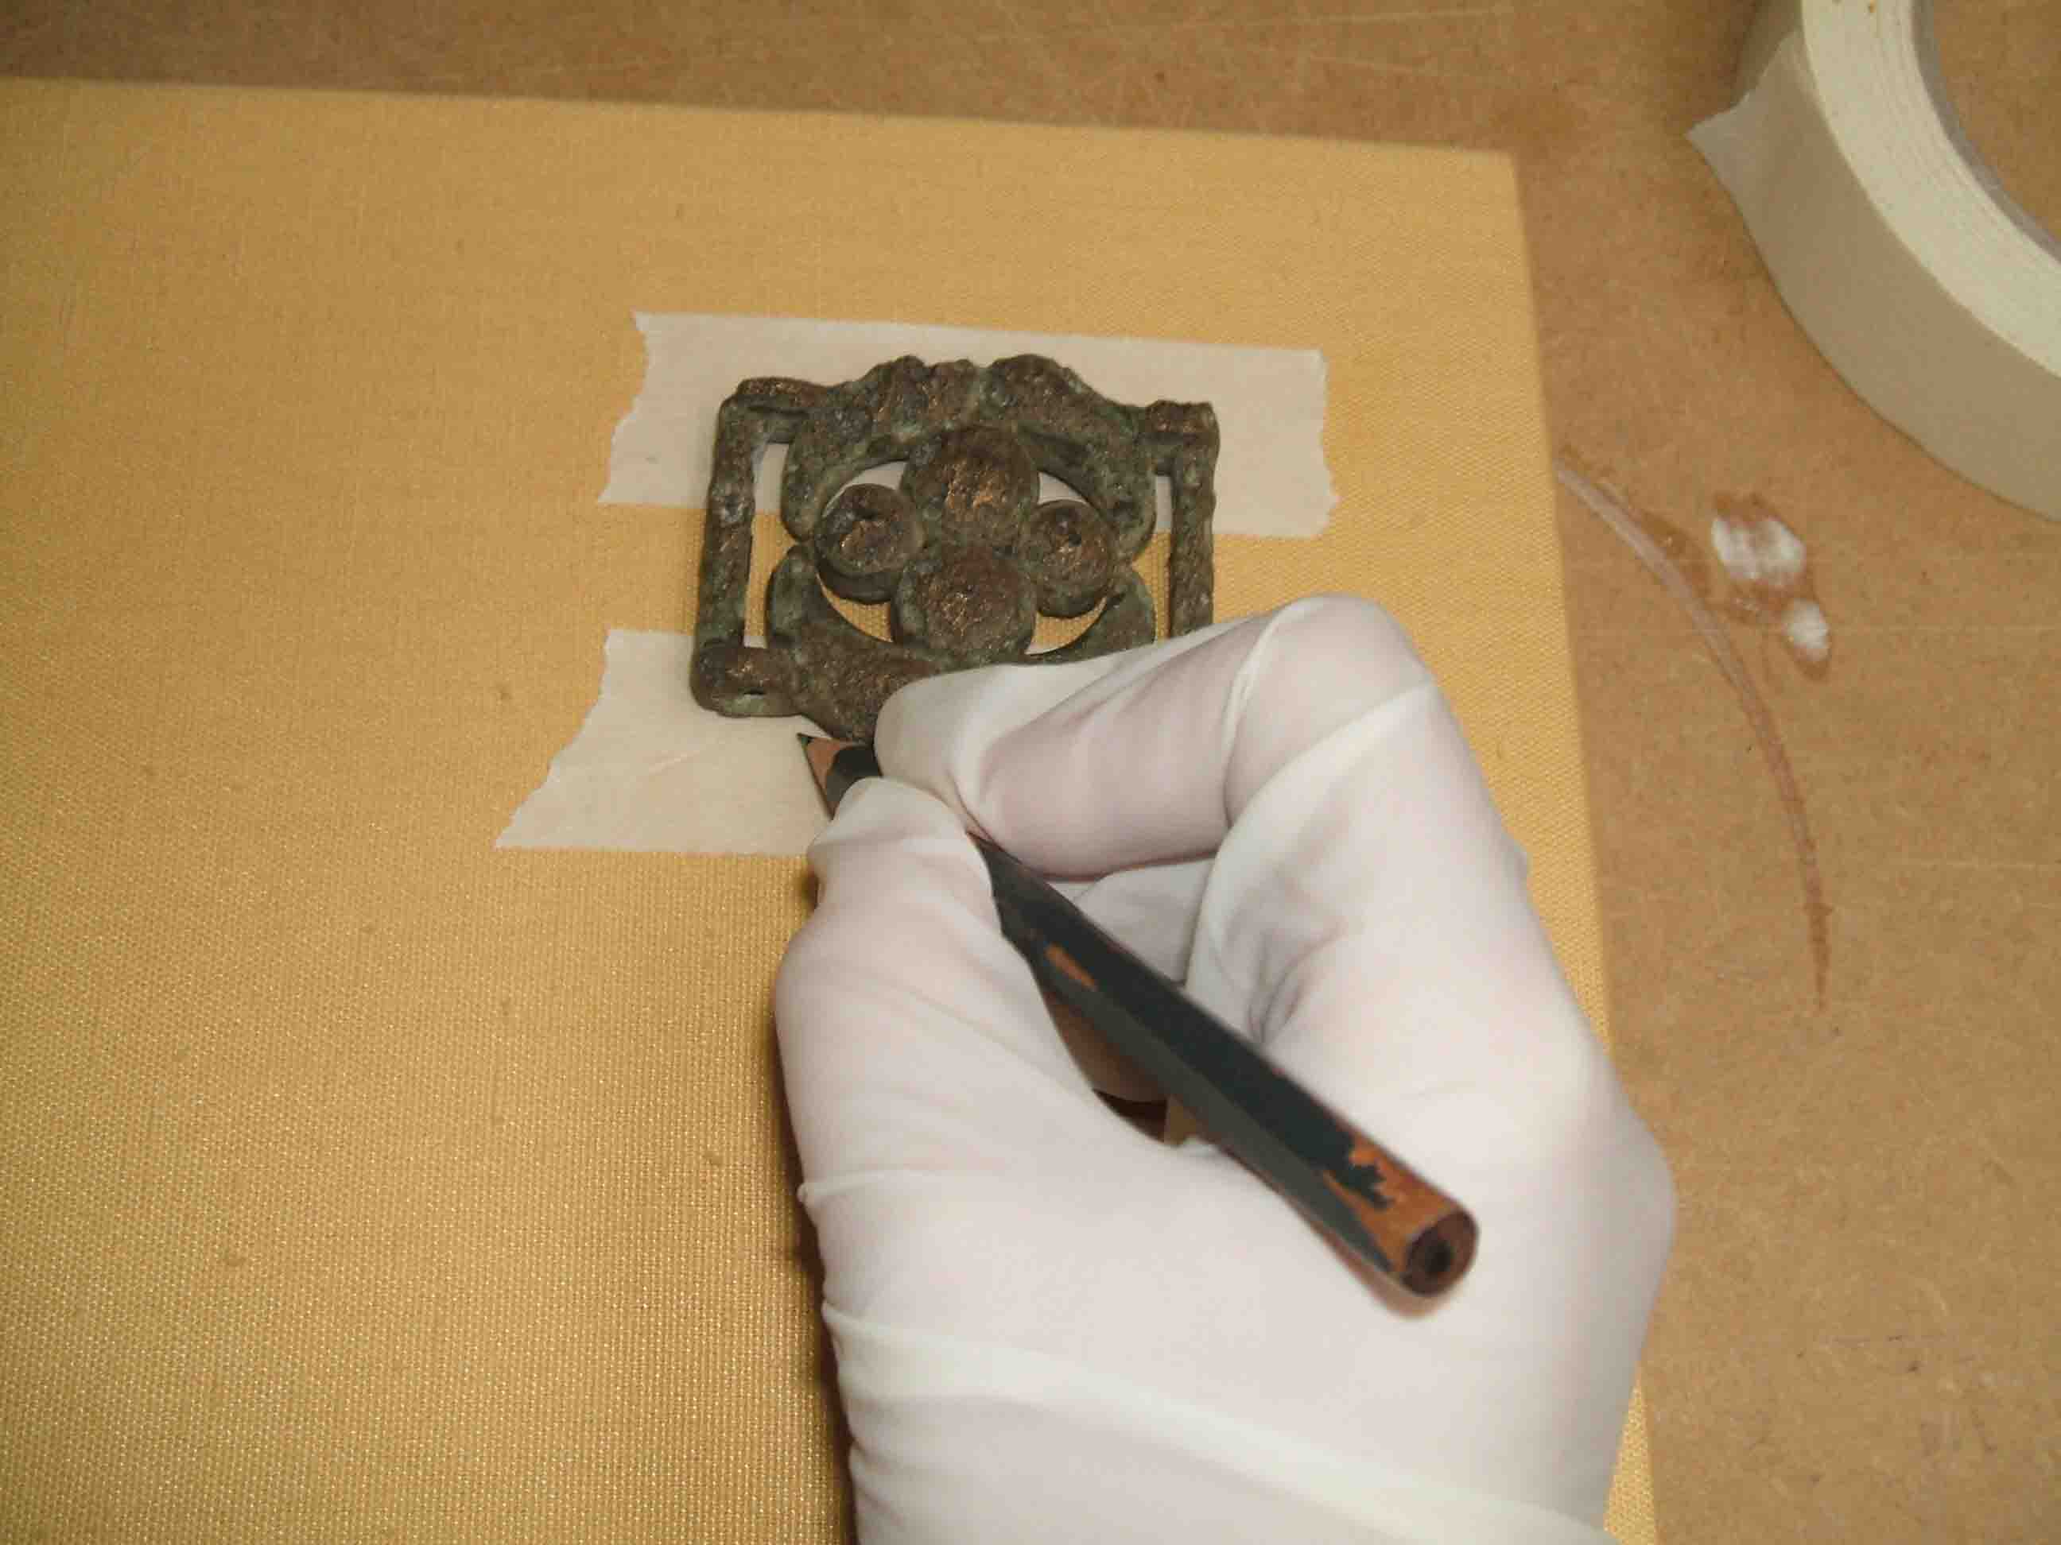

- Remove the object.

- Put on your safety goggles for the rest of the stages.
- Using a very fine drill bit in the dremel drill small holes where you have marked the dots. Do not drill all the way through the board.

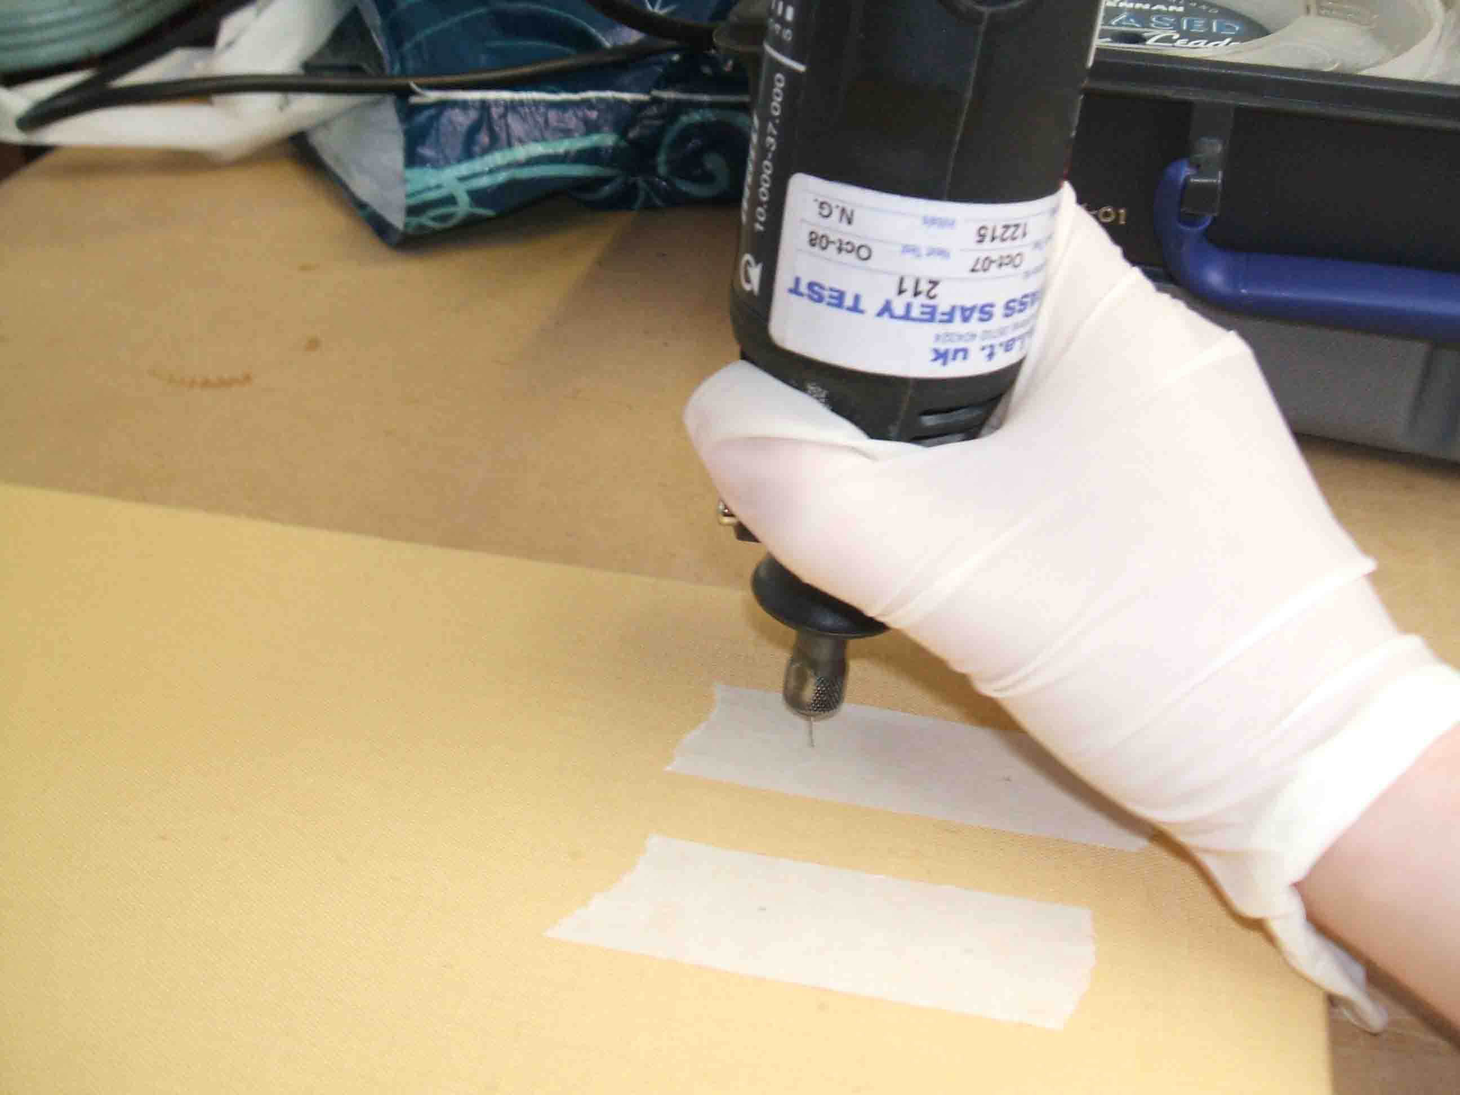
- Choose suitable sized pins to hold the weight of the object, place in the holes and gently tap into the board using the small hammer.

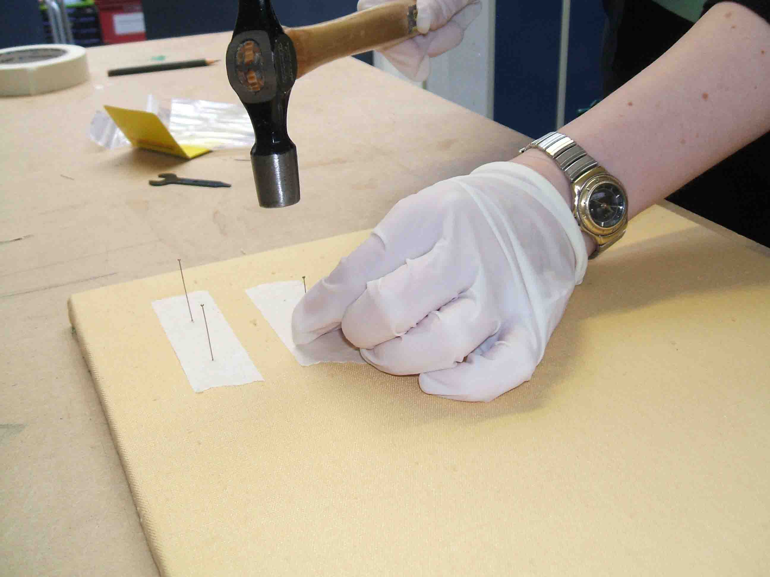
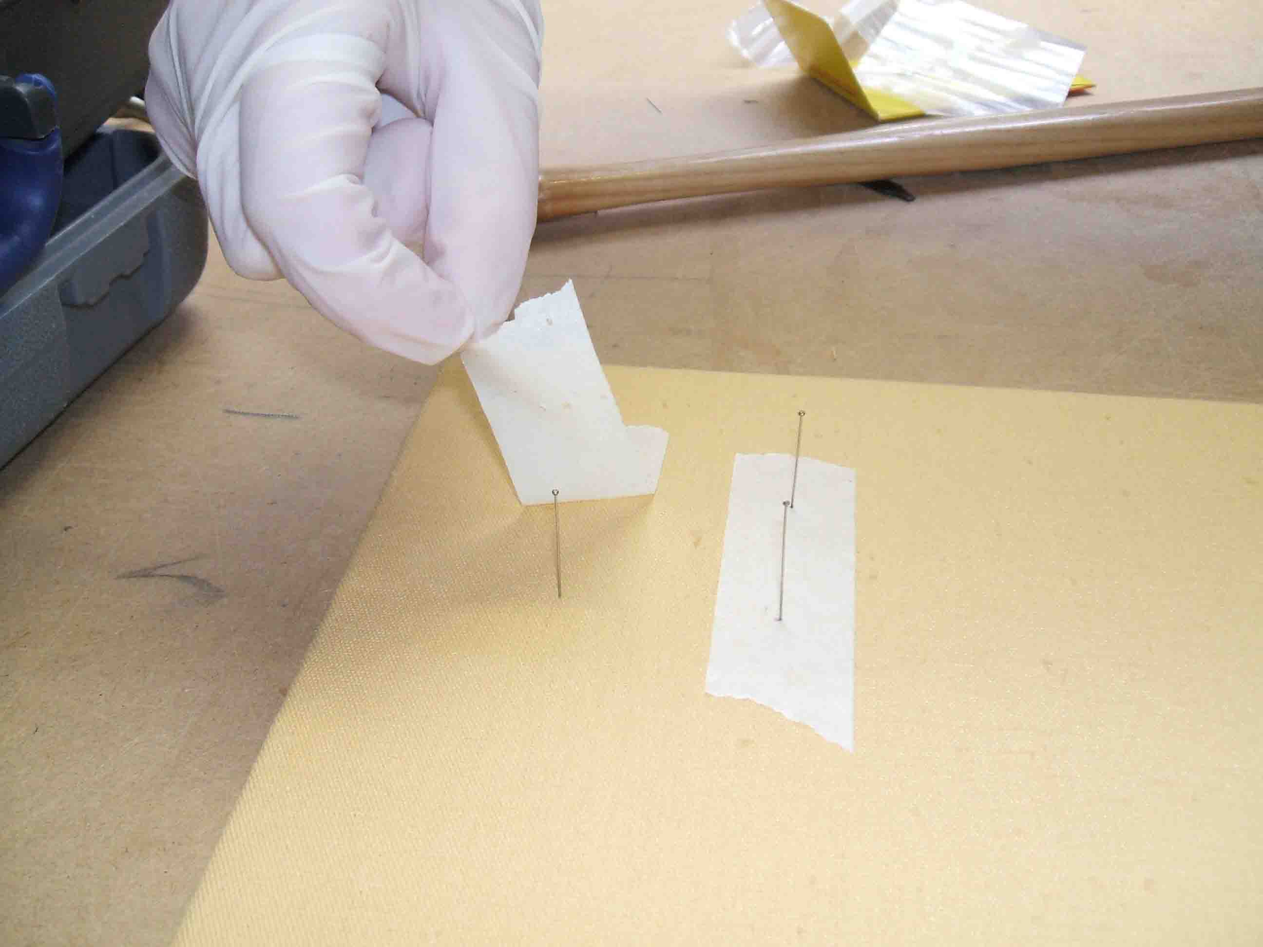
- Remove the masking tape.
- Snip the pin heads off each pin.

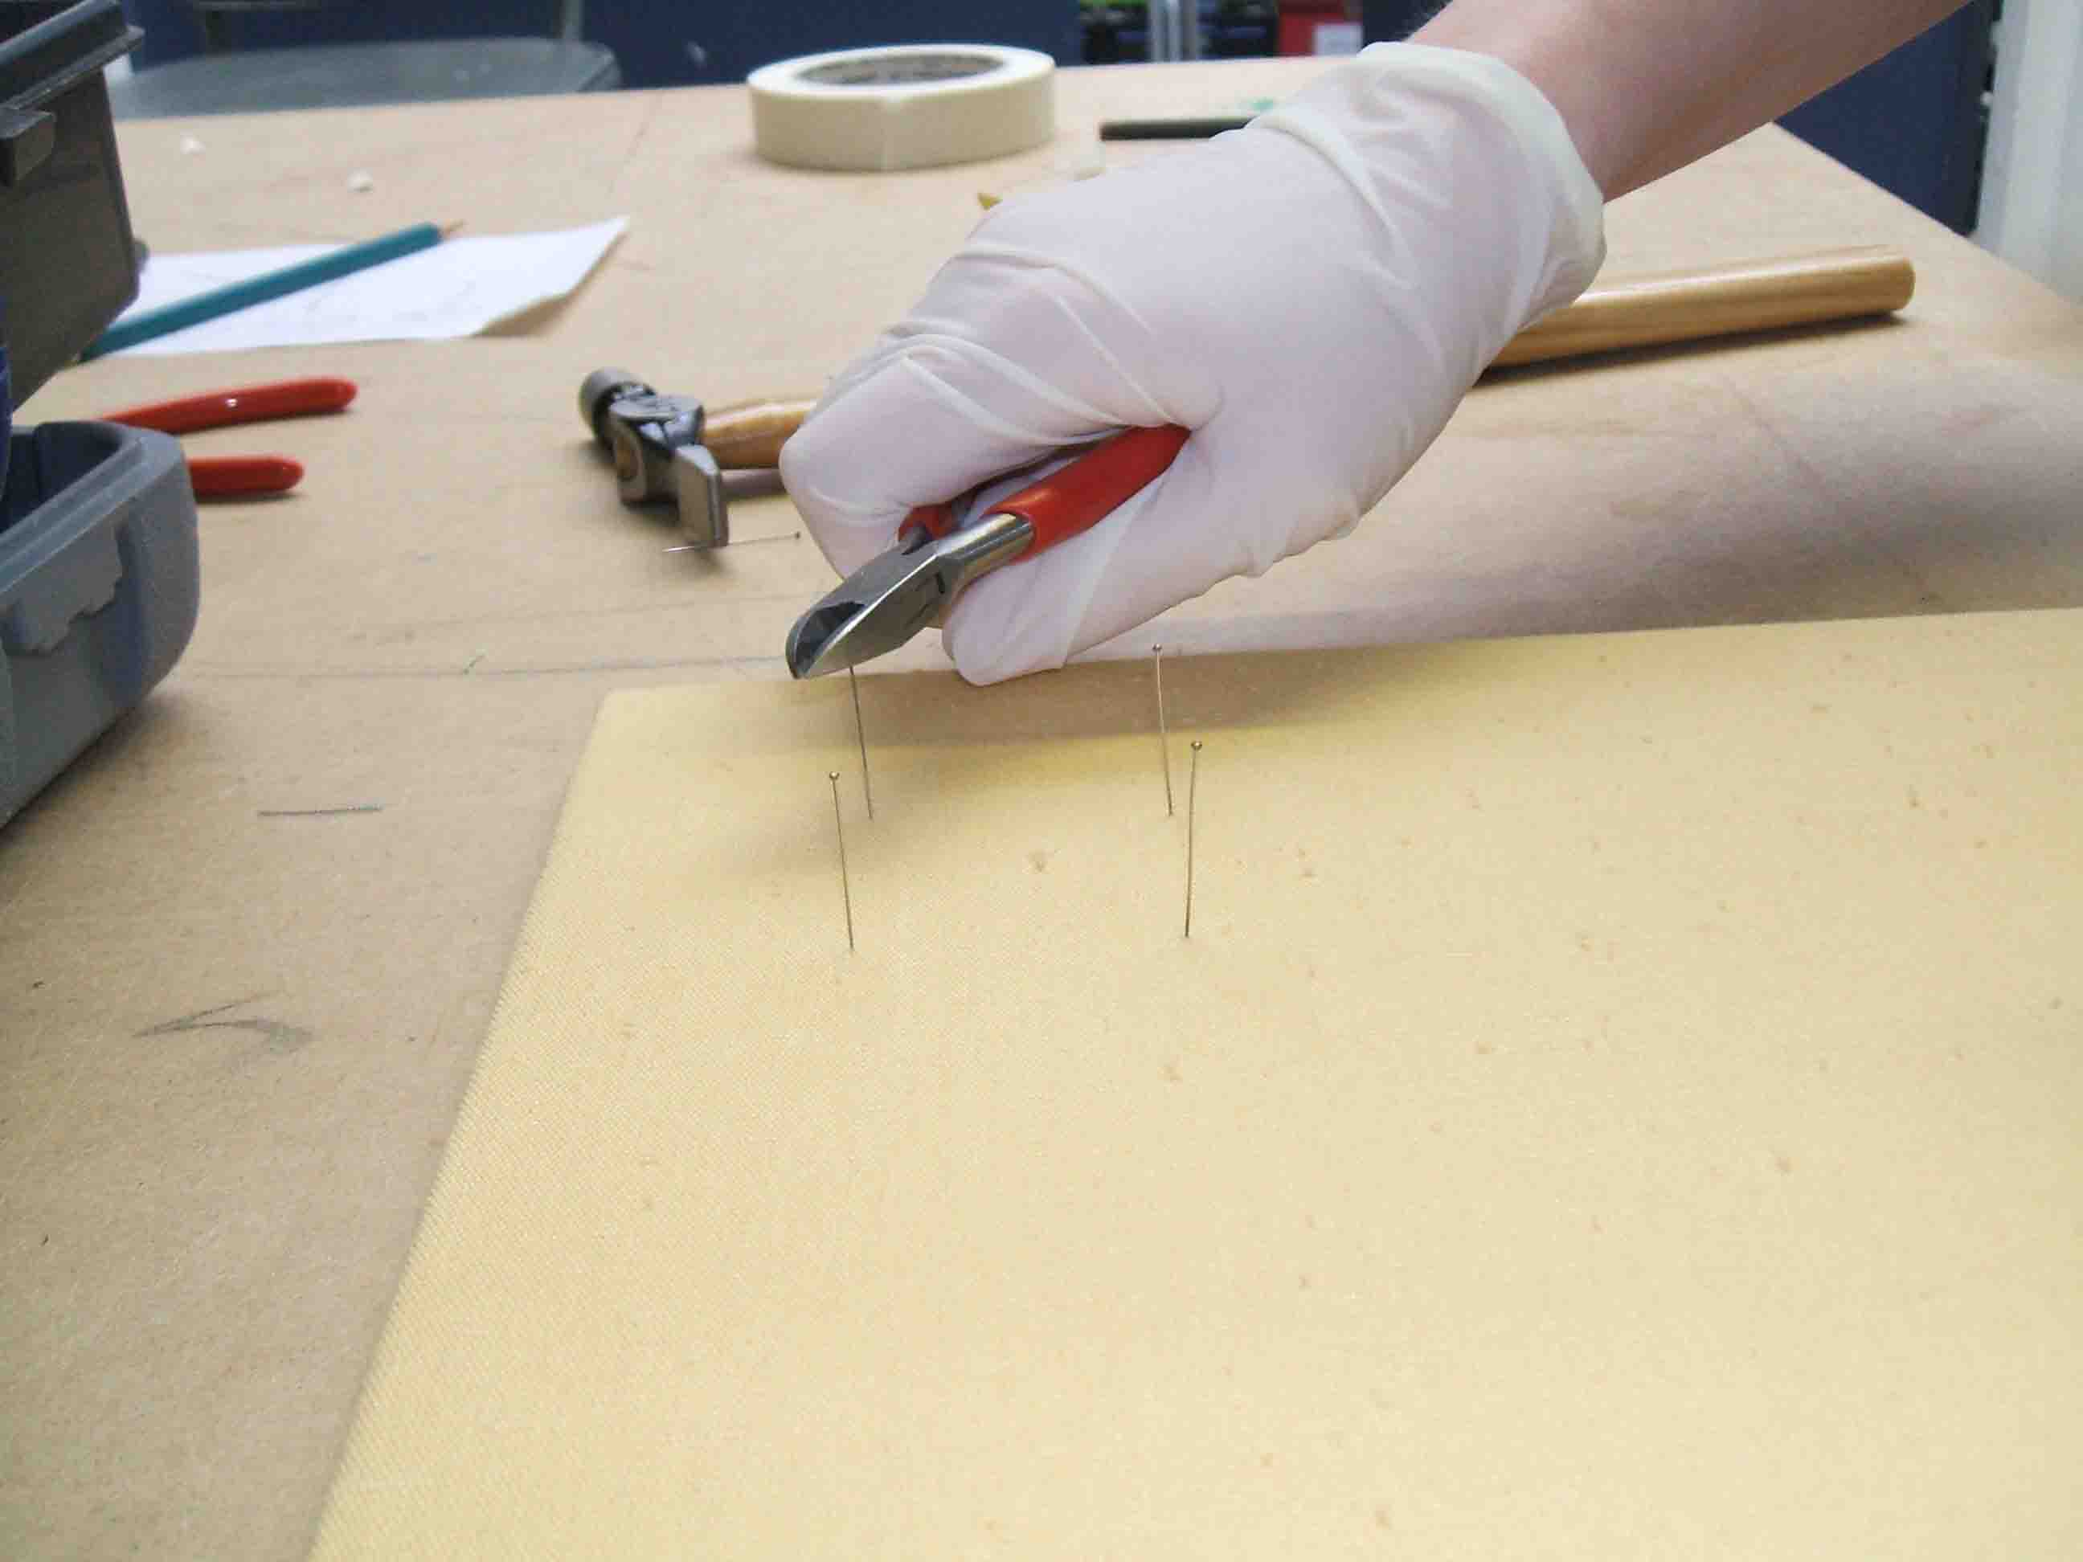

- Carefully place the object back in position. You can put tubing over the pins at this stage if you wish.

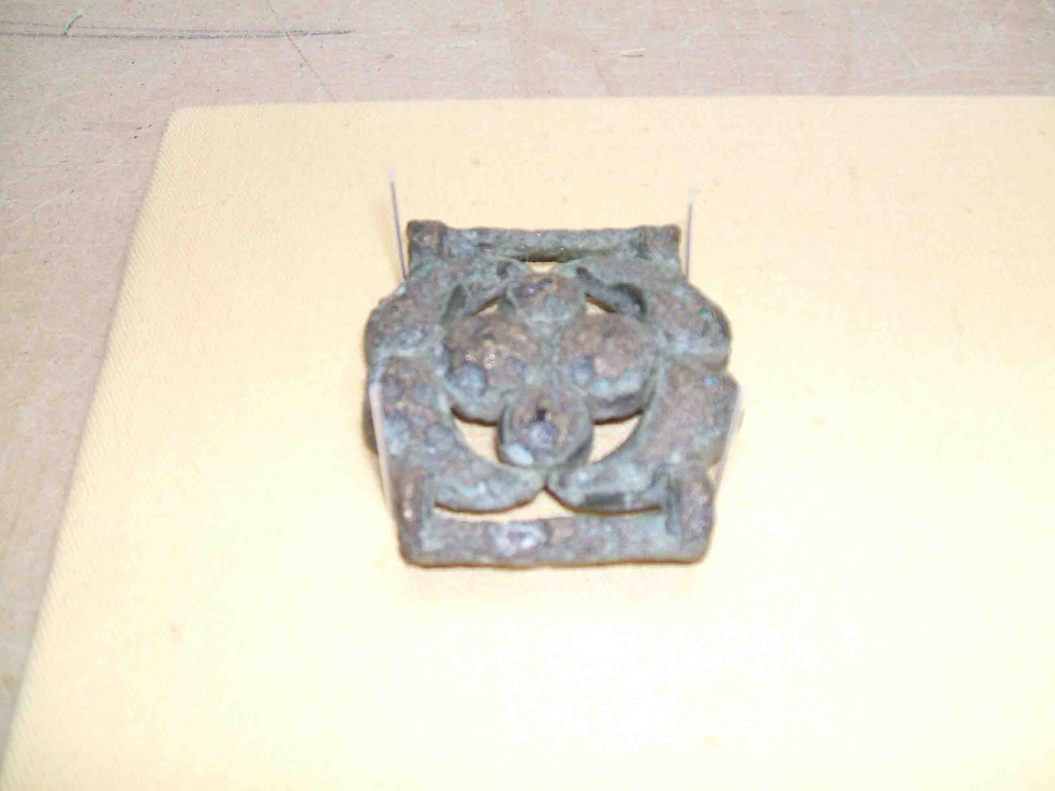
- Mark the pin with a soft pencil where it needs to be bent to hold the object.

- Remove the object.

- Using the small pointed pliers bend the pins so they will support the object.

- Snip off any excess length from the pins and slide tubing over the pin. Cut the tubing at a slight angle and a fraction longer than the pin to protect the object.

- Carefully return the object to the display board. Some pins may need to be bent away and then back in position.

Practice makes perfect so try pinning on stationery, jewellery, coins to perfect your technique!

