Panel and Label Writing
H.E.N
Stockwood Discovery Centre

Guide to writing panels and labels

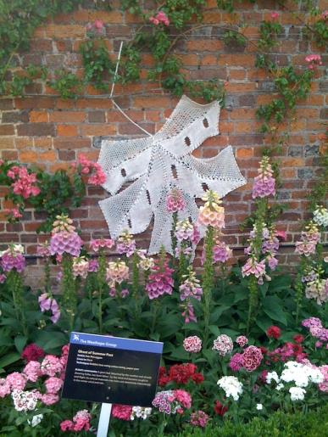
What do you want to say?

Panels or labels for
- Object information
- Health and safety
- Directions
- Donations
- Opening times, admission charges
- Emergencies

Warnings & Notices
  - Allergies
  - Choking hazards
  - Photography – allowed or not
  - Acknowledgements – sponsors, lenders
  - Copyright information – rights given by others
  - Loan information – be careful about giving too much information about the lender or donor – They should give permission as it is covered by the Data Protection Act

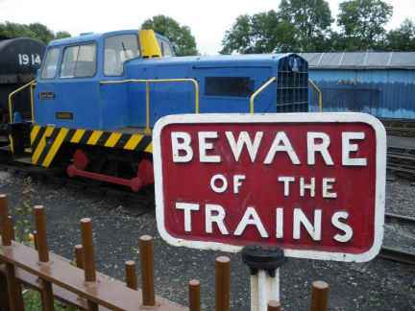
Interpretation development – panels or labels for objects

Interpretation – what we write or illustrate to tell stories or give information

Before you begin ……ask

Where is it needed?

- Inside or outside
- How much room do I have??
- How long does it need to last?
- How much time do I have?
- How much budget do I have?
- Who is going to read it?

Example – Stockwood Discovery Centre

Inside - Permanent Gallery
Size – first gallery space Discovery Hall
Lasts – 10 years
Time – 8 months
Budget - £40,000 (all interactives, graphics, cases etc)
Audience – general family

Content – has to be able to include carriages

A. Determine Overall Gallery Theme
Life’s Journey
Life’s Journey is an exploration of the path that we all travel. This gallery celebrates the different stages of the journey and shares with you stories and memories of the moments that make it memorable.

Develop narrative - determine sections in the gallery
Birth; Childhood & Education; Weddings; Work; Holidays; Health; Social Status; Death

Determine physical structure, based on objects we have to use
1 main panel in each section
Object labels – individual objects and group objects (where cases are small)

Select objects to match the narrative
The objects story – reflecting cultural, social, economic, political events that shape history and the people connected with them.

What to say - Questions to ask

Who is it for?
What do you really want to say?
What do I not want to say?
Do I need a label – is it mentioned somewhere else?
How else can I convey information?
Got too much information - what can I do?
What is the one thing I want people to know about this object?

Panel text guidelines

Use hierarchy of text:
- Use layered interpretation
- Format to be decided by group who might decide on, for example:
  - Bold header
  - Bold first paragraph – to give précis of panel contents -
  - Main body text to give more detailed information
  - Captions can provide additional information
  - Leave a space between paragraphs.
  - Make conscious use of different tones of voice if appropriate
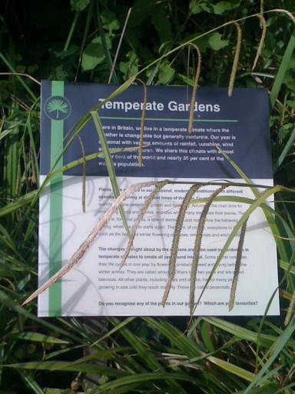

Panel Word count to aim for:
- 150-175 words in main text on panel
- 50 words maximum caption text
- there may be exceptions – fewer words is usually better.

Label Word count to aim for:
- 50 – 70 maximum words text
- there may be exceptions – however fewer words is usually better than more.
- Think about where your label is going. This will also affect the number of words you can use.

Reading age:
- Be aware of reading age, eg.
  - General age 11 yrs old for panels
- Be aware of target audience for publicity & marketing literature
- Be consistent in layout (this is very important to aid people with visual disabilities, or learning disabilities).

Language:
- Active rather than passive
- Use clear and accessible language
- Plain English
- Avoid jargon

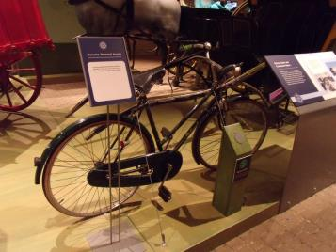
Dates:
- Dates consistent across all panels.
- Use numbers eg. 1880s not 19th century
- Use date ranges 1850s-1900 not 2nd half 19th century.
- Exception is 20th century.
- Seek advice of archaeologist on very early dates, periods.
- Avoid only referring to period by name, give approximate dates eg if writing about the Bronze Age, give rough date range.

Font size & Typeface & style:
- As a general rule, be guided by typefaces such as Arial, Universe and. These are all good examples of clear and legible typefaces. (Luton Life galleries used Universe).
- Avoid simulated handwriting or ornate typefaces.
- Use sans serif, eg. E (sans serif Arial), NOT E –(serif (Times New Roman, little lines at end of letter)
- Capital letters & italicised text harder to read.
- Avoid use of capitals for continuous text.
- Numbers, use typeface where numbers clear, people with sight problems can easily misread 3, 5, 8 and 0.
- Don’t put full stops after title.
- Use as little punctuation as possible, still consistent with meaning.

- 64 point titles
- 52 point main text
- 28 point secondary text
- 20 point captions
- sans serif point style
- Layout consistent across all panels
- Clearly defined areas of colour, same information in same place on each panel (following recommendation and request of Access Advisory group).

Contrast:
- The better the contrast between the background and the text, the more legible the text will be.
- Contrast will be affected by size and weight of type.
- Black text on white background provides best contrast
- If using white type, make sure the background colour is dark enough to provide sufficient contrast.

Setting text:
- Avoid fitting text around images if this means that lines of text start in a different place and are therefore difficult to find.
- Don’t put text over images
- Don’t justify paragraphs
- Try to avoid a line of text running onto the next page, or splitting a paragraph over two pages.

Style:
- Use the same format for each type of label or panel
- Use logos where needed – Funders, donors
- Use complementary colours
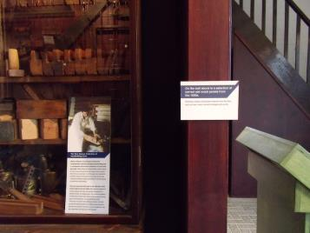

Museums Luton - proofreading conventions

Use… | Rather than…
,about 1840 | c.1840, circa 1840, around 1840
One to ten in words, then 11 upwards using numbers
In the 1800s | In the nineteenth century, in the C19th  The exception is the 20th century
In the 1860s | In the 1860’s
1850s - 1900. | second half of the 19th century
Medieval | Mediaeval
Lent by Mrs Jones | On loan from Mrs Jones
By kind permission of the British Library (unless the owner specifies exactly which words to use) | Photograph by kind permission of the British Library
Dates as well as historical periods, eg if writing about the Bronze Age, give rough date range as well.

Write out numbers from one to ten. From 11 upwards use the numbers
50cm (20 inches)
6,000 | 6000
750 AD  750 BC  but drop the AD after 1,000 AD (eg in 1066) | 750AD, AD 750  750BC
3 March 1993 | 3rd March, 1993
70 per cent | 70%
ageing | aging
Anglo-Saxon | Anglo Saxon
Beaker Folk | beaker folk
brick making | brick-making
bumble-bee | bumblebee, bumble bee
Celtic | Celtic
Cretaceous Period, Eocene Period etc for prehistory periods | Cretaceous period etc
Danelaw | danelaw, Dane Law or dane law
Devil’s Pit | Devils Pit
Dunstable Priory | Dunstable Friary
environmentally-friendly | environmentally friendly
fertiliser | fertilizer
field walking | fieldwalking
focused | focussed
forward-thinking | forward thinking
Governess Cart (use upper case for all proper names of horse-drawn vehicles) | governess cart
hand axe | handaxe or hand-axe
handmade | hand-made, hand made
Hansom Cab (use upper case for all proper names of horse-drawn vehicles) | hansom cab
honey bee | honey-bee, honeybee
horse-drawn | horse drawn
horsepower | horse-power, horse power
hunter-gatherers | hunter gatherers
Justices of the Peace | justices of the peace
lacemaking | lace making, lace-making
lorries | trucks
make-up (as in face make-up) | make up
magistrate | Magistrate – when referring to Crawley Family
medieval period | Medieval Period
Members of Parliament | members of Parliament
Mr Green, Mrs Green, Ms Green, Dr Green, Joe Green Jnr, Joe Green Snr | Mr. Green, Mrs. Green, Ms. Green, Dr. Green, Joe Green Junior, Joe Green Senior
North west | North-west
Postman | Post man
Postboy | Post boy
Puddlehill | Puddle hill
rakemaker | rake-maker
Samian ware | Samianware
Second World War | 2nd World War, II World War
stable block | stableblock
Totternhoe Roman villa | Totternhoe Roman Villa
trackway | track way
waterlogged | water-logged
watertight | water-tight
Waulud’s Bank  Dray’s Ditches  Bradger’s Hill | Wauluds Bank  Drays Ditches  Bradgers Hill
weathercock | weather cock
Well-known | Well known
woodturning | wood-turning

Making your own labels

Materials
- Foam core
- Mount card
- Paper - printed or photocopy
- Scalpel
- Double sided tape or spray glue

Laminate or not
- inside only
- consider how it will be attached

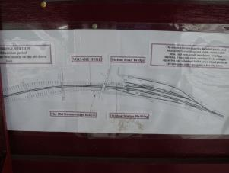
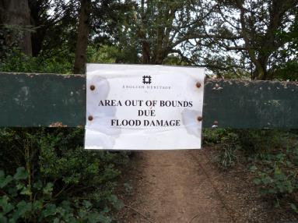
Using a print company

- What material?
  - Foamex
  - Banners
  - Fabric
  - Vinyl
- Can they print from your software layout?
- Need to determine size for all labels
- Get a quote
- Obtain a sample to check quality
- Check that all spelling is correct
- How will you send graphics?
- Make sure they understand your instructions
- Make sure all images are high enough resolution to print out at the size you require – think 3mb per image minimum
- Will they cut them out for you?
- How will you stand them?
- How long will it take?
- How will they be delivered?

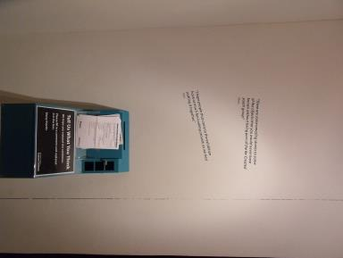

Installation

Do you install at the same time as objects?

What do you use?
- Stands
- Double sided tape
- Cable ties
- Frames

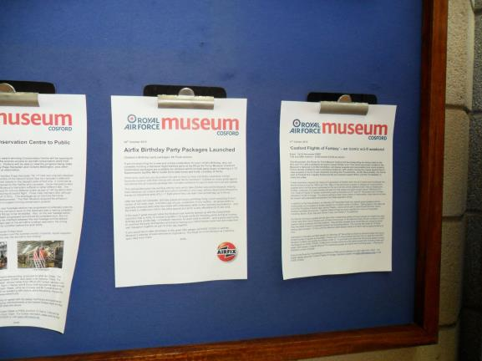
Stand suppliers

3D Displays
www.3ddisplays.co.uk

Dauphin
www.dauphin.co.uk

Sign Holders Direct
www.signholdersdirect.co.uk

Morplan
www.morplan.com

