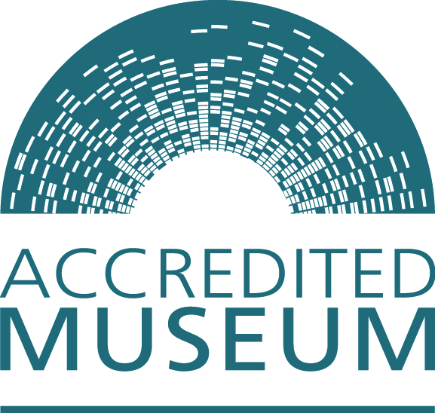 | 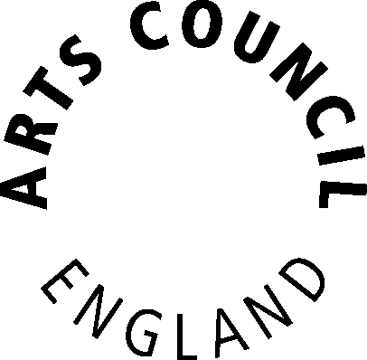

Accreditation Scheme for Museums and Galleries in the United Kingdom

Museum mentor expression of interest
Contents

What is a museum mentor and why are they needed? | 3
The museum mentor role | 3
What is this form for?  What are the benefits of becoming a Museum Mentor? | 4  4
How will the information be used? | 4
What will happen next? | 4
What can I do if I disagree with an outcome of ‘non-eligible’? | 4
Museum mentor expression of interest | 5

What is a museum mentor and why are they needed?

The Accreditation Scheme sets nationally agreed standards for museums in the UK. The Standard supports museums in identifying opportunities for further improvement and development. Accreditation began as the Museum Registration Scheme in 1988, initially with an emphasis on ethical governance and collections management.

To fulfil the requirements of Accreditation all museums must have access to appropriately qualified professional staff. This can be through employing qualified and/or experienced staff or, if this is not possible, through the mentor scheme. Mentors work in partnership with museums, and local museum support services to ensure the museum has access to the advice it needs.

The museum mentor role

Museum Mentors help museums in developing their Accreditation application and subsequent Accreditation returns. Mentors play a vital role in supporting museums which do not have paid professional staff within their workforce. For some people the mentor role forms part of their job description while for others it is a purely voluntary role.

Museum Accreditation covers all aspects of a museum’s business and it is unlikely that a single person will have the full range of professional skills to advise on all areas of the Standard with the same level of expertise. One museum professional must fulfil the role of mentor in order to sign off the museum’s Accreditation application. That does not mean that they have to work alone. Mentors come from a range of backgrounds and may invite colleagues to help on specific areas or bring relevant expertise into the museum in other ways. The mentor needs to be aware of and co-ordinate, when appropriate, the advice that the museum is receiving. The mentor:

- provides support and advice relating to Accreditation from their own expertise.
- confirms the Accreditation application and Accreditation return, and provides a report as part of the Accreditation return.
- works with the museum to establish what other areas of expertise are required to meet and maintain Accreditation standards.
- acts as an ‘advice co-ordinator’, identifying sources for advice from their own networks or through other professionals.
- acts as an advocate for the museum and helps the museum to develop links and relationships with the wider museum profession.

Further information relating to the mentor role is available within the museum mentor handbook, published on the Arts Council England website: http://www.artscouncil.org.uk/about-us/museums-and-libraries/museums/accreditation-scheme/.
What is this form for?
Museum mentors are appointed by individual museums rather than any of the Accreditation assessing organisations. In order to support this process in England, Arts Council England has developed a process by which potential museum mentors can be identified, and their details made available to museums. The purpose of this form is to enable museum professionals to express an interest in becoming a Museum Mentor. The information provided will be reviewed against the published eligibility criteria, which are:

- a minimum of five years experience working professionally in museums, with recent experience at curator/manager level. At least three years should be in an area of competence relating to Accreditation - organisational health, collections, or users and their experiences

- a relevant or linked qualification

- a commitment to career-long continuing professional development (CPD). This could be through participation in formal CPD channels, such as the Museums Association’s AMA and CPD+ schemes, or through logging CPD activity on a CV

What are the benefits of becoming a Museum Mentor?
The Museum Mentor role benefits the museum receiving support as well as Mentor, and their employer (where employed). Mentoring provides an opportunity to broaden your scope of activity within the museum sector, away from the specific focus of your day job. The role enables new contacts to be formed and developed, and new ways of working to be explored. Taking on the role will also be useful experience as CPD to add to your portfolio and CV. The mentor scheme in England is coordinated by Arts Council England, and you will receive regular updates, along with invitations to events and activities, typically twice a year.

How will the information be used?

Information provided on, or attached to/with this form will only be used for the purposes of determining eligibility as a museum mentor. If you are confirmed to be eligible, then copies of the information will be held by Arts Council England for future reference. See ‘Declaration’ section for further details.

What will happen next?

The information provided will be reviewed against the published criteria. If eligibility is confirmed you will be invited to complete a ‘museum mentor profile form’ which will include similar information to that requested within the expression of interest form, and which, with your agreement, will be made available to those museums seeking museum mentor support.

What can I do if I disagree with an outcome of ‘non-eligible’?

Eligibility reviews in England will be undertaken by Arts Council England. Appeals should be made in the first instance to the Accreditation Manager based at Arts Council England using the following email: accreditation@artscouncil.org.uk.
Museum mentor expression of interest

Contact details

Title:

First name:

Last name:

Job title/position:

Correspondence address

Postcode
Telephone number:

Email address:

Please indicate whether these details are personal or business:
Personal |  | Business

Experience

Please detail your relevant professional experience

Role | Organisation | Start Date | End date
Brief description of responsibilities

Role | Organisation | Start Date | End date
Brief description of responsibilities

Role | Organisation | Start Date | End date
Brief description of responsibilities

Role | Organisation | Start Date | End date
Brief description of responsibilities

Qualifications

Please detail your relevant qualifications

Qualification | Awarding body | Award date

Continuing professional development

Please detail your activity in relation to continuing professional development

Activity | Associated organisation | Date/s

Key skills
Please list below those areas of activity undertaken by a museum that you consider to be your key skills:

Requirement | Description | Tick
1.1 | Clear statement of purpose
1.2 | Acceptable constitution for the governing body
1.3 | Appropriate management arrangements
1.4 | Effective forward planning
1.5 | Secure occupancy of all premises containing collections
1.6 | Demonstration of financial basis
1.7 | Appropriate workforce
1.8 | Access to professional advice and input to policy development and decision making
1.9 | Clear, workable emergency plan
1.10 | Organisational approach to environmental sustainability
2.1 | Satisfactory arrangements for the ownership of collections
2.2 | Development policy
2.3 | Documentation policy
2.4 | Care and conservation policy
2.5 | Documentation plan
2.6 | Care and conservation plan
2.7 | Documentation procedures
2.8 | Expert assessment of security arrangements
3.1 | Good-quality services and development
3.2 | User-focused experience
3.3 | Effective learning experiences

Area of activity

Please indicate below where you would be willing to undertake the role of museum mentor

For example, UK, East of England, Herefordshire

Declaration
Arts Council England, and where relevant, third party assessing organisations, will collect and use the information provided within this form for the purpose of considering eligibility as a museum mentor for the purposes of the Accreditation scheme. Forms relating to individuals in Wales, Scotland and Northern Ireland will be made available to the appropriate assessing organisations (CyMAL: Museums Archives and Libraries Wales, Museums Galleries Scotland or the Northern Ireland Museums Council respectively).

Arts Council England will not share any of the information provided with third party agencies or organisations other than where the relevant responsibilities transfer to another Government agency and the transfer of information related to your application is required or where transfer of information is legally required. The information will be maintained securely at all times at Arts Council England in line with the requirements of the Data Protection Act. A copy of Arts Council England’s Data Protection policy is available on request.

I declare that I have understood this notice and that I am content with the information that I provide to be used in this way.

To be signed as appropriate by the individual completing the expression of interest form.

Signed:

Name:

Date:

