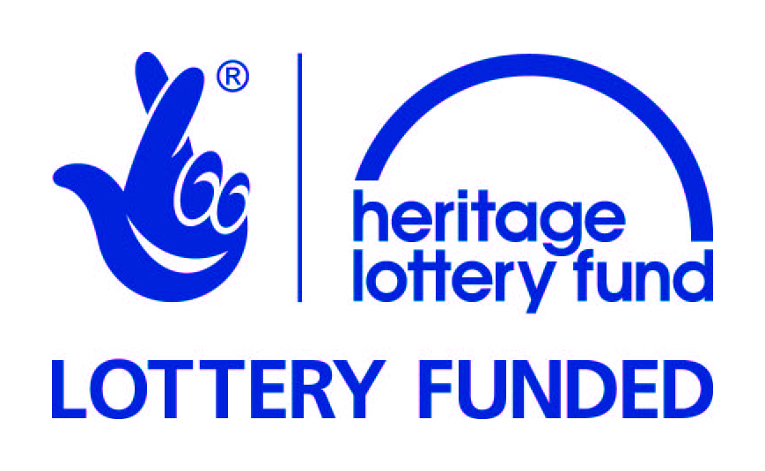
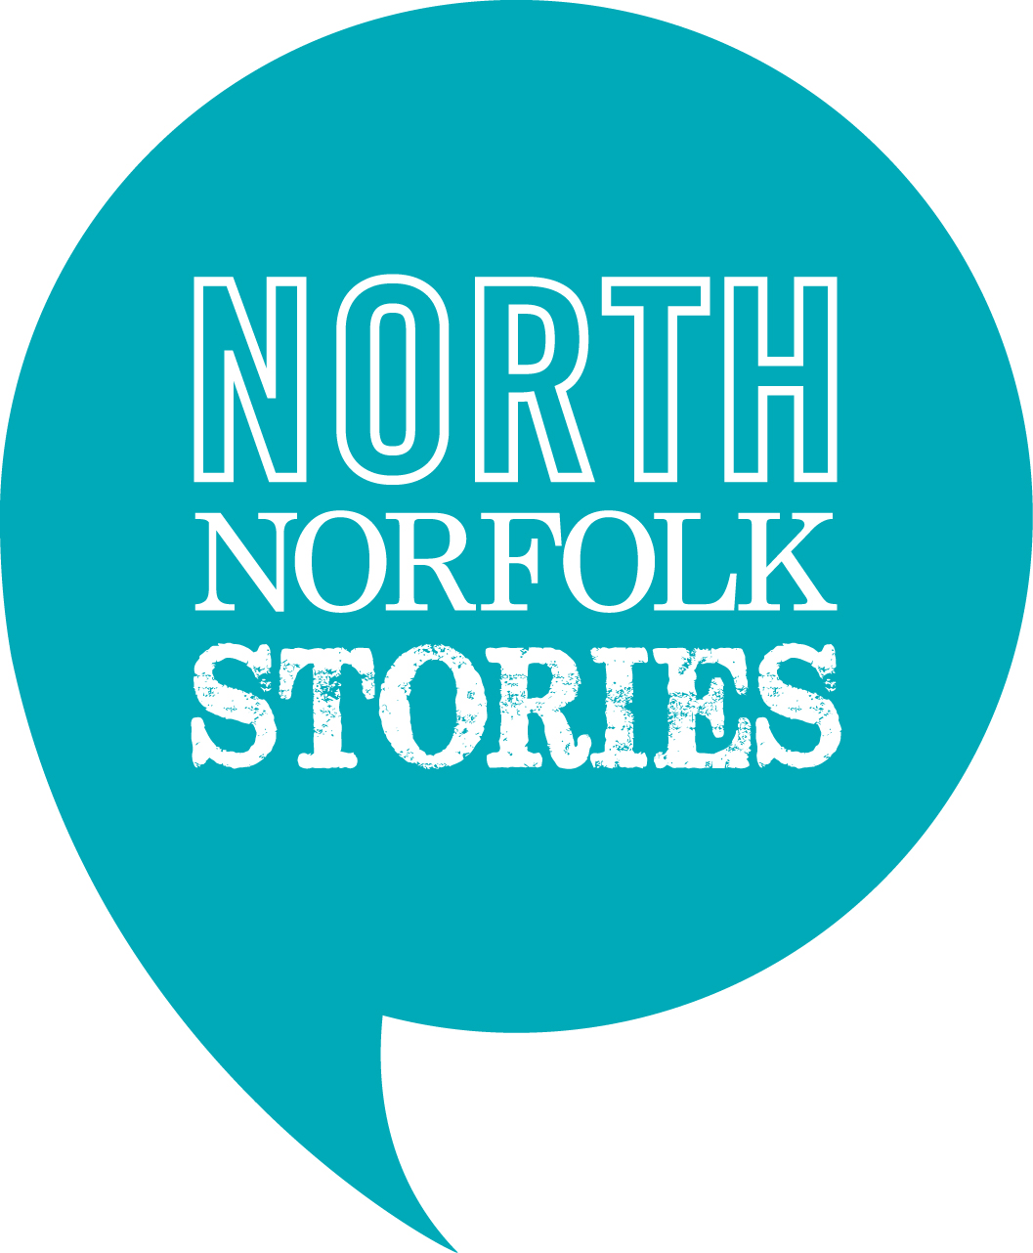

Note: At the beginning of April we’ll be sending out an online questionnaire to participants who’ve signed up at that point so trainers can all tweak the content of their sessions to ensure that, as much as possible, it meets the needs of the participants.

Saturday 11 April, 10am – 12noon

How to Sell Your Events

Trainer: Christina Lister, PR and communications consultant

Do you find it difficult to fill your events? Do you know you need to market your events more effectively but aren’t sure where to start? This short, introductory session will offer practical guidance and support about how you can effectively market your events. The session will be tailored to suit participants’ needs but will cover items such as:

- Drafting and issuing news (press releases)
- Speaking to the media and doing media interviews
- Setting up and running photo opportunities for media
- Social media in a work capacity
- Creating and issuing e-newsletters

This course is aimed at anyone who would like to develop marketing skills, or anyone with responsibility for events. Participants do not need any prior knowledge of PR or marketing.

Saturday 11 April, 12.30 – 2.30pm

An Introduction to Volunteer Management

Trainer: Katrina Siliprandi, Museum learning development consultant

Are you new to volunteer management, or keen to develop your skills in this area? This short, introductory session will offer practical guidance and support about how to effectively work with, and manage, volunteers. The session will be tailored to suit participants’ needs but will cover items such as:

- The difference between staff and volunteer management
- Advising, supporting and developing volunteers
- Attracting and recruiting volunteers
- Motivating volunteers and recognising their achievements

This course is aimed at anyone who would like to develop volunteer management skills or learn more about working with volunteers. Participants do not need any prior knowledge of volunteer management.

Saturday 11 April, 2.45 – 4.45pm

An Introduction to Event Management

Trainer: Hannah Jackson, Sustainability project officer, Norfolk Museums Service

Do you want to know the secrets of running an engaging, successful event? Do you want to understand more about the practicalities of running both large and small events? This short, introductory session will offer practical guidance and support about how to effectively manage events of all sizes. The session will be tailored to suit participants’ needs but will cover items such as:

- Aims and objectives of hosting events
- Identification of key audiences, their needs and requirements
- Resourcing of activities, including working with freelancers and contractors
- Event planning, including logistics, visitor flow/timings, communication strategies
- Operational items, e.g. Risk Assessments, Insurance and Licensing
- Evaluation and visitor feedback

This course is aimed at anyone who would like to develop event management skills or learn more about running successful events. Participants do not need any prior knowledge of event management.

Sunday 12 April, 10am – 12noon

An Introduction to Income Generation

Trainer: Vanessa Trevelyan, Museum consultant

Do you know you need to generate more income but are not sure where to start? Do you want to find out about different ways in which you can generate income? This short, introductory session will offer practical guidance and support about how to effectively generate income for your museum. The session will be tailored to suit participants’ needs but will cover items such as:

- Overview of the various means of generating income
- How income generating activities can add value to a cultural or heritage experience
- Income generating activities that can be carried out by volunteers
- Producing a basic fundraising plan
- Sources of suitable further advice

This course is aimed at anyone who would like to develop fundraising skills, or learn more about how to generate income for a museum or other cultural venue. Participants do not need any prior knowledge of income generation.

Sunday 12 April, 12.30 – 2.30pm

An Introduction to Customer Service

Trainer: Helen Johnson, Library Manager, Norfolk Library and Information Service

Do you want to know the secrets of excellent customer service? Do you want to understand more about how staff and volunteers can ensure visitors have the best possible experience at your museum? This short, introductory session will offer practical guidance and support about how to deliver superb customer service. The session will be tailored to suit participants’ needs but will cover items such as:

- What is customer service
- Who are our visitors and what would good service look like to them
- Attitude and approach to customer service e.g. creating a good first impression, understanding body language, how to deal with queries and ask the right questions
- What problems might our visitors might encounter and how should we deal with them
- Creating happy customers out of complaints

This course is aimed at anyone who would like to develop or improve customer service skills. Participants do not need any prior knowledge of customer service.

Sunday 12 April, 2.45 – 4.45pm

An Introduction to Peer-to-Peer Mentoring

Trainer: Katrina Siliprandi, Museum learning development consultant

Do you want to understand how peer-to-peer mentoring could help develop your practice and the practice of your colleagues? Do you want to know how you can be both a mentor and mentee to colleagues? This short, introductory session will offer practical guidance and support about how to develop and carry out informal mentoring relationships with peers. The session will be tailored to suit participants’ needs but will cover items such as:

- What an informal peer-to-peer mentoring relationship might look like
- How to give and receive feedback and constructive criticism and use it to improve practice
- How to listen actively and ask open questions
- How peer-to-peer mentoring can empower staff and volunteers

This course is aimed at anyone who would like to learn more about peer-to-peer mentoring. Participants do not need any prior knowledge of mentoring, and do not need to currently be in a mentoring relationship.

