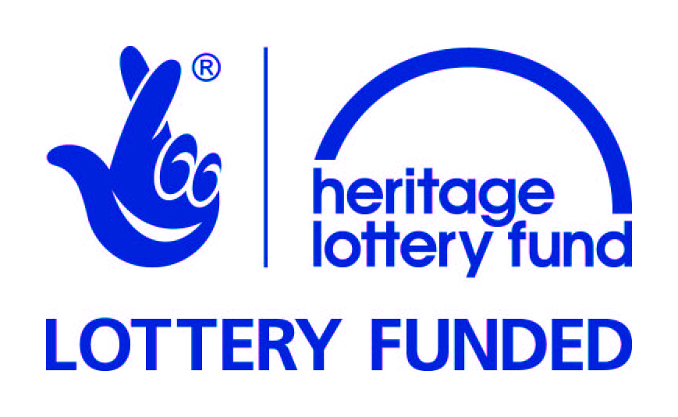

North Norfolk Stories Training Weekend
RNLI Henry Blogg Museum
The Rocket House, The Gangway, Cromer, Norfolk, NR27 9ET

NB: Participants are welcome to come to as many sessions as they would like.

Saturday 11th April 2015

9.45 Arrival and Introductions (with refreshments)
10.00 Christina Lister: PR and Marketing
12.00 Lunch (Please provide your own. The Rocket House Café at Henry Blogg Museum willopen if participants wish to buy lunch.)
12.30 Katrina Siliprandi: Volunteer Management
14.30 Tea and coffee
14.45 Hannah Jackson: Event Management
16.45 Close
Sunday 12th April 2015

9.45 Arrival (with refreshments)
10.00 Vanessa Trevelyan: Income Generation / Fundraising
12.00 Lunch (Please provide your own. The Rocket House Café at Henry Blogg Museum will be open if participants wish to buy lunch.)
12.30 Helen Johnson: Customer Service
14.30 Tea and coffee
14.45 Katrina Siliprandi: Mentoring (session will be about how to undertake peer-to-peer mentoring, and how to give constructive criticism)
16.45 Close/feedback

