Stonger Together conference, Langley Academy 15 May 2015
Report - Judith Carruthers
What is Stronger Together?
www.langleyacademy.org/strongertogether
This was an ACE funded project across Berkshire, Buckinghamshire and Oxfordshire and comprised of 11 partnership projects between secondary schools and museums. Lead partners were the Langley Academy and River and Rowing Museum.
“The aim of this project was to test whether the ethos and practice of museum learning at the Langley Academy could be extended to benefit other children and young people. By museum learning, we mean how we use real things, real stories and real people to inspire teaching and learning, and how schools and museums can work in partnerships to develop initiatives with richer outcomes for all participants.”
The weblink above gives you a comprehensive guide to the project and tips on how to run similar projects.
How it worked
Timescale: between July 2014 and February 2015-06-18
Budget: main source is ACE strategic support grant of £138,600
Thirty bursaries were created to support secondary school teachers and museum professionals to enable them to work on these projects. Involvement was through an application process. It was easier to secure take up from museums than schools but the project had full participation and no organisations dropped out during the course of the project.
The project managers matched the schools and museums up rather than allowing the participants to choose - primarily done through what made most sense logistically. Each project had to focus ideally on at least two curriculum areas. The number and age of students varied in each project.
To kickstart the project, a ‘speed dating ‘event took place where all the organisation had a chance to briefly interact with all other organisations. The course of the project was then mainly, partners planning and delivering their individual projects.
The projects were classic examples of high quality creative museum school partnerships:
For example:
- The Langley Academy & Amersham Museum: worked with Year 8 Students in a Drama and ICT project in which they recreated the story of the Amersham Martyrs through a promenade performance and created an app for the museum.

- Mathew Arnold School and Victoria & Albert Museum: worked with Year 7 History & Art project, exploring crossovers between studying art and history including developing a new model for thinking about transferable higher-order thinking skills which they nicknamed DAIV (describe, analyse, interpret, value).

Other aspects of the project
- Research

Built into the project were three research projects which are all available for download:

- Digital technology
- New National Curriculum
- Internationalism

- Evaluation
The project was evaluated by Kings College London, using a Continuing Professional Development model.
- Spreading benefits beyond participants’ organisations.

This conference and a website were built into the project.

Recommendations for similar projects
- Main sustainable outcomes were around skills development for the professionals involved in the project rather than on what impact it had on the students participating. Such a project could therefore be promoted as a CPD vehicle rather than on measuring impact on students which is always harder to establish.

- Working with partners which they had not chosen, whilst initially awkward for some, was not a barrier in developing high quality partnerships. As ever, the important factor for success was the enthusiasm and commitment of the staff involved and the fact that once teachers visited the heritage sites which in most case they had not visited before, they then saw potential for pertinent creative learning.

- Invite high level stakeholders from outside the sector to such conferences:
At the conference itself, there was an impressive number of influential professionals from outside the museum sector e.g. opening the day was the local MP. This is what gave the day its buzz and feeling that important developments were being rolled out rather the nature of what was being discussed.

- Building in the research increased the legacy of the delivery projects which were all time limited.

- A longer timescale was needed according to most participants particularly as the initial planning took place over the summer holidays.

Langley Academy
The most impressive aspect of the day was visiting Langley Academy and seeing how museum learning is embedded in its daily curriculum:
http://www.langleyacademy.org/pages/specialismkeyfoci.html
- Currently three staff with a museum learning remit work there (mixture of full time and part-time)
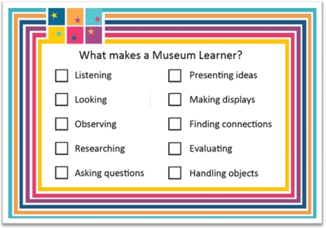

- Each classroom has this poster detailing the skills of a Museum Learner :
http://www.langleyacademy.org/pages/museumlearning.html

- Objects such as a rowing boat and plane are on display in their entrance foyer (on loan from museums such as Imperial War Museum). The school itself was designed by Norman Foster
http://www.fosterandpartners.com/projects/langley-academy/

.

