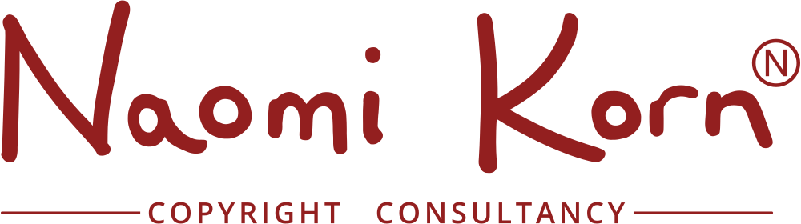

Copyright – Key points to remember
What is copyright?
- Copyright is mainly based on the Copyright, Designs and Patents Act 1988, subsequent revisions including the Copyright and Related Rights Regulations 2003, Copyright Rights in Performances Regulations 2014 previous Copyright Acts (1911 and 1956), Directives, Treaties, Conventions and Case Law.

- Copyright is an exclusive economic right granted to the creator of original work to permit or prevent other people from copying it.

- Copyright does not protect an idea, only the material expression of the idea.

- Works are protected regardless of artistic merit, although they need to be original and/or show skill and judgement.

What does copyright protect?
- Copyright only protects certain things specified by the Copyright Act - if it does not fall within one of the eight categories – it will not be protected

- These categories are: Literary works, Dramatic Works, Musical Works, Artistic Works, Broadcasts, Sound Recordings, Films and Typographic Works

How are works protected?
- There is no need to register copyright in the UK: it exists automatically as soon as a work in one of the above categories is fixed

- There is no need to use a copyright symbol in the UK, if a work is protected by copyright, it will be protected anyway

What are “Moral Rights”?
- Moral Rights relate to the creator’s honour or reputation. They give the creator:
- The right to be named as the creator of the work (paternity right)
- The right to object to someone wrongly named the creator of his/her work (false attribution right)
- The right to object to derogatory treatment of the work (derogatory treatment right)

- Moral rights can’t be assigned to anyone else (unlike copyright), but they can be waived.

Disclaimer: None of the information contained within this document should be construed as legal advice. Should specific legal advice be required, please consult the appropriate legal advisor.

© Naomi Korn, 2016. Some Rights Reserved. The information here is licensed for use under a Creative Commons Attribution Share Alike Licence (CC BY SA)

