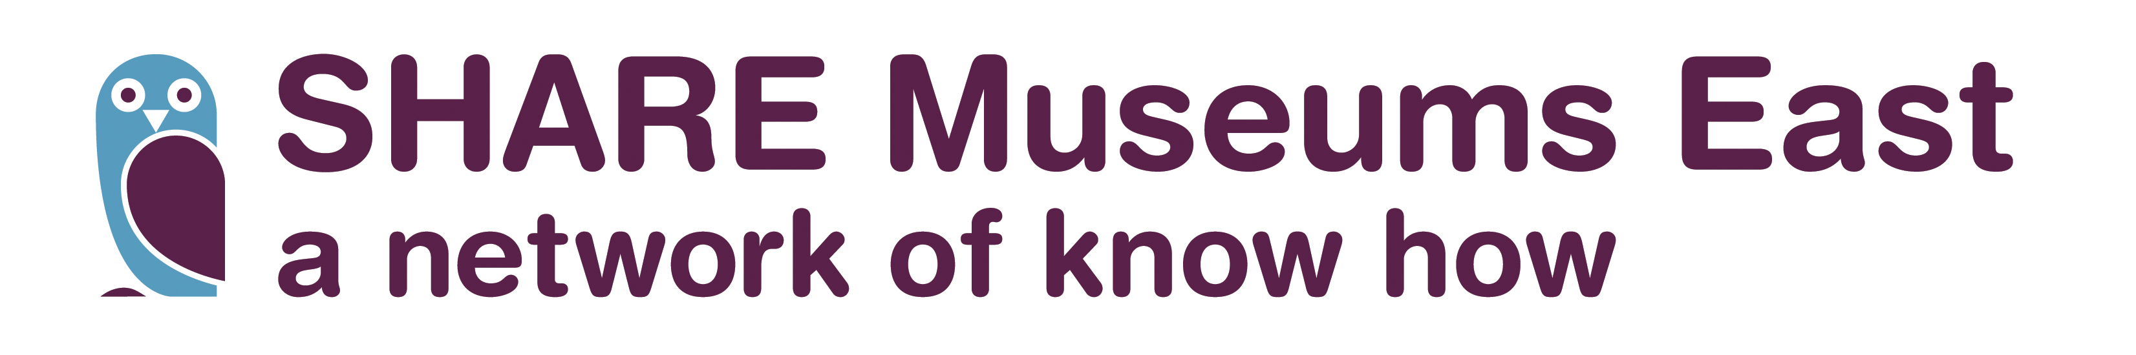

Museum Futures Grants: Information for Museums
SHARE Small Grant Scheme 2017-18
Deadline Tuesday 14th November

Introduction
As part of our 2015-18 regional Museum Development activity plan, funded by Arts Council England, SHARE Museums East is supporting museums to develop their Vision and their Business/Forward Plans.

Museum Futures – small grants
Museums can apply for a grant up to a maximum of £1200 (or £1600 depending on circumstances). The grant form is available from the SHARE Museums East website.
Examples of activities for which the grant can be used include:
- 1-1 support, such as working with a forward planning consultant for tailored support in creating your Vision, writing, developing or reviewing your forward plan.

- Support for wider consultation, for example costs towards staging events or focus groups with volunteers, staff, stakeholders, users and non users.

- Collection and evaluation of audience data to inform forward planning.
If you are unsure if what you are applying for is eligible for a grant please speak to your MDO or a member of the SHARE team. We are happy to talk it through with you.

Grants eligibility and criteria
Accredited museums and those officially Working Towards Accreditation from across the region are invited to apply. We particularly welcome applications from museums who attended the SHARE Training sessions on Museum Futures in October
Museums where at least two people participated in the October training can apply for up to £1600. Other museums may apply for up to £1200.
It will help your application if you show clearly:
1. how you intend to use the grant to support your business/forward planning process.
2. that you are registered as an Accredited museum or Working Towards Accreditation.
3. that you ave the support of your county MDO (and Museum Mentor if applicable).
4. that you can demonstrate how the grant will support the museum’s development plans.
5. the support and engagement of your governing body or managing committee in the forward planning process.
6. that you are prepared to share their experience of the process with other museums

Exclusions
Applications will not be considered:
• To cover the costs of activities taking place before a grant offer is made.
• By museums that are not Accredited or actively working towards Accreditation.
(National Museums or ACE Major Partner Museums can only be considered as a secondary priority.)

How to apply
• Application forms are available to download from www.sharemuseumseast.org.uk.
• You must include a breakdown of the costs of the proposed activity.

What happens after you apply
• Applications will be acknowledged (by email).
• Applications will be evaluated by the SHARE Museums East team.
• A decision will be provided by Monday 20th November 2017.

Grant offer and payment
• Successful applicants will receive an offer letter by email. This will confirm the amount of the grant and any special conditions applied in addition to the general expectations set out in this document.
• The offer letter will be accompanied by a grant contract. To accept the development grant on the terms offered, the contract must be completed, signed and returned.
• The grant payment will be made on behalf of SHARE Museums East through Norfolk County Council.
• Grants may not be used for any other purpose than that stated in the application form and offer letter.
• Successful applicants will be asked to provide feedback on the process as part of the project evaluation. This will be in the form of an initial report (a form will be provided), then followed-up over a longer-period in order to assess longer term impact.
• Any publicity about the grant award must acknowledge that it has been funded by a grant from the SHARE Museums East Museum Development Programme, supported using public funding by Arts Council England. Logos are available on request by email to sharemuseumseast@norfolk.gov.uk.

How to claim your grant
Once your grant contract has been signed and returned, Norfolk County Council will issue you with a purchase order number.
Please then invoice us for your grant, quoting that order number.

After the development activity has taken place, recipients will be required to submit a completed report (template will be available.)
- Please keep a copy of the paid invoice(s) from the consultant etc and relevant receipts for other expenses in case we need to ask you for these.

Key dates
Deadline for grant submission Tuesday 14th November 2017
Grant decisions available Monday 20th November 2017
All money must be spent and report in to SHARE 23rd February 2018

SHARE team contact for these grants is Sally Ackroyd, Museum Development Project Officer.
Tel: 01603 638141 Email: sally.ackroyd@norfolk.gov.uk

