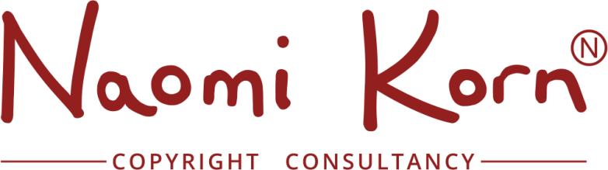

Worksheet: IP Quiz: I Depending upon the question, choose either true or false

- Intellectual Property Rights protect creations of the mind?
TRUE / FALSE

- Intellectual Property Rights can be bought, sold, rented, gifted and bequeathed?
TRUE / FALSE

- Copyright protects original ideas?
TRUE / FALSE

- Copyright is automatic and does not require registration?
TRUE / FALSE

- Most web content can be reused freely?
TRUE / FALSE

- If you own a work you can freely copy and repurpose it?
TRUE / FALSE

- The onus of responsibility lies with the user of a work to get permission, even if the rights holder is unknown or cannot be traced?
TRUE / FALSE

- Works can be used without permission and with minimal risks, if a disclaimer is used?
TRUE / FALSE

- If you buy music from iTunes, you can then listen to it, play it in public, use it in other products and perform it?
TRUE / FALSE

- If you commission a work, you will automatically own the rights?
TRUE / FALSE

