HERITAGE TEAS
A semi-bespoke retail tea product for your gallery, museum, etc.

- A perennially popular low-price gift to sell in your shop
- Tea blended for the water in your area
- 50% profit on retail
- Low minimum order
- Low origination cost
Join a network of cultural enterprises and benefit from cross-promotion to an audience of loyal, enthusiastic visitors
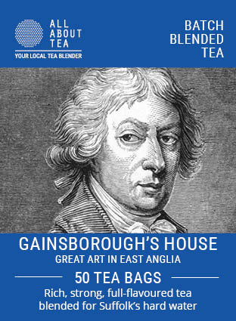
HOW IT WORKS

We have produced a standardised full-colour label with a panel for a design that captures the essence of your operation – for example, a famous painting or piece from your collection, or an image of your site.
Your brand and our brand both appear on the label
We produce the design with advice from you.
We own the product and will sell it in our own shop/website – which benefits you because it gives extra exposure to you.
Minimum order 100 units
Two formats: tin or stand-up pouch both containing 50 teabags

INDEPENDENT OR AS A GROUP

INDEPENDENT: Origination cost (design and print setup) £75. Your name is prominent in the design

GROUP: eg “Art of East Anglia” or “Museums of Norfolk”.
Reduced origination charge just £25 per site (because we save
a lot of sales/admin time when producing tea for a number of
sites).

PRICING

Distributor prices assume annual sales of 1200 units (mixed between tins/pouches)

Product | Min order | Expected Annual Sales (mixed) | Price | RRP | POR
Pouch | 100 | 100 | 2.25 | 3.99 | 44%
Pouch | 200 | 1200 | 1.60 | 3.99 | 60%
Tin | 100 | 100 | 3.60 | 6.49 | 45%
Tin | 200 | 1200 | 2.50 | 6.49 | 61%

Setup costs £75 (reduced to £25 for members of a group)
Delivery cost FREE to UK addresses excl Highlands and Islands
£15 to European addresses
Lead time One week from receipt of payment to delivery

WHAT TO DO NEXT:

- Call Andrew or Scott at All About Tea on 023 9275 0122
- Tell us a little about what you do
- We will put a mock-up together (turnaround 3 days)
- Decide product and quantity required (min 100)
- We will issue a Proforma invoice and commence work
- Lead time from receipt of payment to delivery: one week

We look forward to hearing from you

ANDREW GADSDEN
Managing Director
All About Tea
andrew@allabouttea.co.uk

