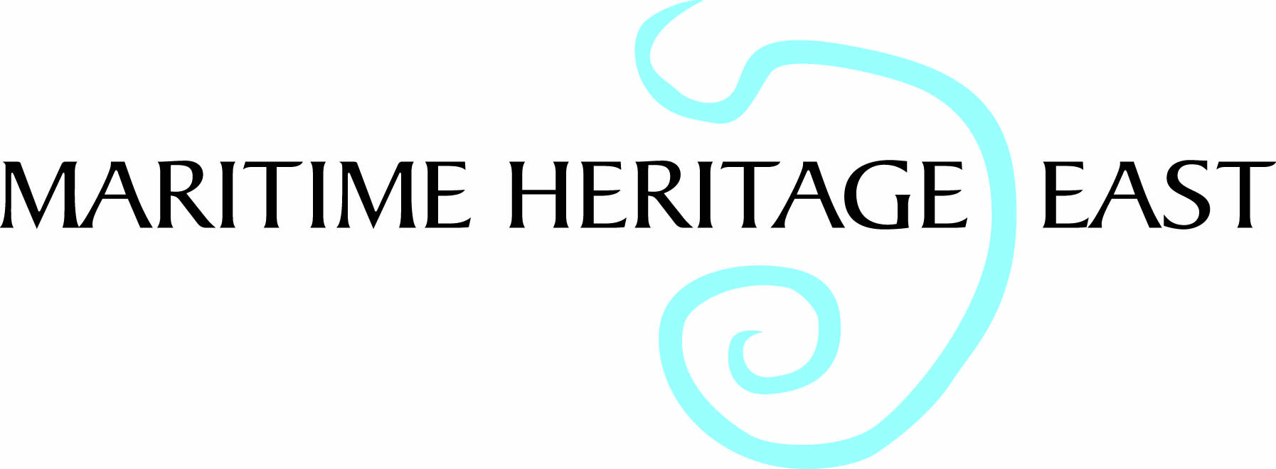

MHE Conference East Anglian Maritime Heritage, Past, Present & Future
University Campus Suffolk, Waterfront Building, Neptune Quay, Ipswich IP4 1QJ Saturday, 21st May 2016

PLANNED PROGRAMME

10.00 Registration and Coffee

10.30 Introduction:- Des Pawson MBE

Morning Session Chaired by Des Pawson

10.35 Suffolk Estuaries-Scandinavian Ships:- Paul Constantine

11.05 Beach Boats of East Anglia:- Robert Simper

11.35 Thames Titanics:- Luisa Hägele, Southend Museum Service

12.05 Keeping the Past Sailing into the Future:- Stephanie Valentine

12.35 Panel of 4 for questions chaired by Des Pawson

12.55 Buffet Lunch

First afternoon session chaired by Clare Hunt, Southend Museum Service.

2.pm “The provision of sailcloth to the 16th century Navy: John Collins and others of Ipswich, and their decline.” :- Susan Maxwell

2.30 Ipswich Wet Dock: a story of Riches to Rags and back again:- John Field

3.00 A Present from Yarmouth: the cultural impacts of the seasonal East Anglian herring fishery on Scottish fishing communities of the late 19th to mid 20th centuries:- Linda Fitzpatrick, Scottish Fisheries Museum.

3.30 panel of 3 for questions Chaired by Clare Hunt

3.45 Break for tea

Last session Chaired by Dr Erich deWald UCS

4.05 I DO LIKE TO BE BESIDE THE SEASIDE: The Story of Harwich & Dovercourt Bay Holiday Resorts:- David Whittle, Harwich Society,

4.35 ‘Life’s a Beach’ Leisure and Consumption of the Seaside.:-
Ciara Phipps Southend Museums Service

5.05 panel of 2 for Questions Chaired by Dr Erich deWald UCS

5.15 – 5.30 Final Questions and Comments.

Tickets for the day £15 to include coffee and finger buffet lunch

To obtain a booking form, either e-mail peter@bendall88.fsnet.co.uk or write to
M.H.E., 25 Brunswick Road, Ipswich, IP4 4BP

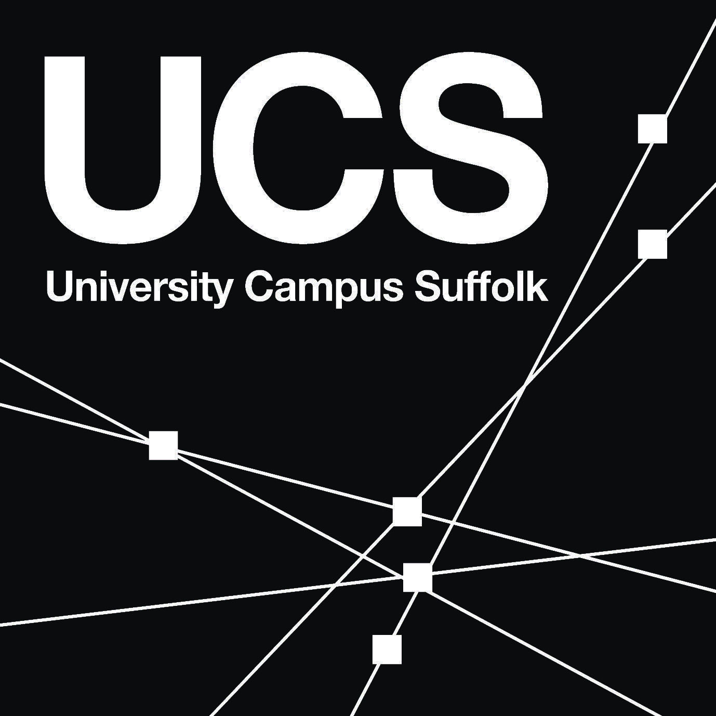 | 

