SHARE Mystery Shopping Scheme
What sort of experience do your visitors get?
Join in to find out!
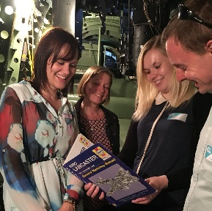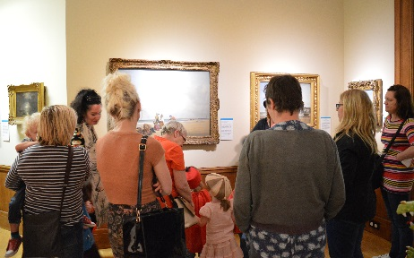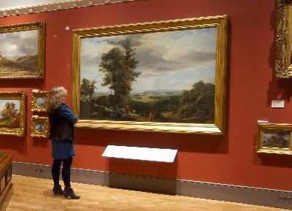
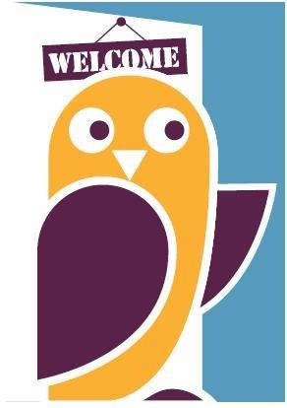
We are looking for museums to take part in our Mystery Shopping Scheme for 2017
Each museum will receive three ‘mystery shopping’ visits, resulting in a report with comprehensive feedback on all aspects of your visitors’ experience. The data is useful for improving your visitor offer, developing front of house training and supporting funding bids.
In return your museum staff or volunteers will make three mystery shopping visits to other museums.
“Great opportunity to look at what we do and how we do it through ‘new eyes’.”

Register your interest before 12th May
email sharemuseumseast@norfolk.gov.uk or telephone 01603 495881

For more information please see the SHARE website at sharemuseumseast.org.uk

“useful with external funders”

Essential training days for the scheme are available on 19 or 20 May.
Book on to one of them at www.sharemuseumseast.org.uk/events

