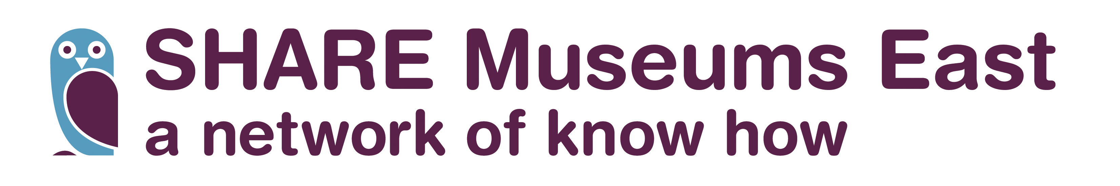

Making the Most of Loans
SHARE Small Grant Scheme 2016-17
Deadline Monday 13th February

Introduction
As part of our 2015-18 regional Museum Development activity plan, funded by Arts Council England, SHARE Museums East is supporting museums to forge stronger links with National museums to increase loans to smaller museums. We want the museums receiving the loans to get the most out of these opportunities, and so are launching a small grant scheme across the region.

Making the Most of Loans – small grants
Museums can apply for a grant up to a maximum of £1500. The grant form is available from the SHARE Museums East website at: http://sharemuseumseast.org.uk/loans-small-grants/
Examples of activities for which the grant can be used include:
- Transport and packing costs for loans
- Photography of loans for use in events and publicity
- Events/activities inspired by or in association with a loan e.g. a trail, leaflet or handling kit
- Publicity materials for loans, or exhibitions that feature the loan e.g. poster, graphic panel
- Conservation and condition report costs for loans
If you are unsure if what you are applying for is eligible for a grant please speak to your MDO or a member of the SHARE team. We are happy to talk it through with you.

Grants eligibility and criteria
Accredited museums and those officially Working Towards Accreditation from across the region are invited to apply. We particularly welcome applications from museums which have been awarded a Ready to Borrow or Small Scale Capital Grant in 2015-17. It will help your application if you show clearly:
1. How you intend to use the grant to support your forward planning process.
2. That you are registered as an Accredited museum or Working Towards Accreditation.
3. Have the support of your county MDO (and Museum Mentor if applicable).
4. That you can demonstrate how the grant will support the museum’s development plans.

Exclusions
Applications will not be considered:
• To cover the costs of activities taking place before a grant offer is made.
• By museums that are not Accredited or actively working towards Accreditation.
• From National or ACE Major Partner Museums.

How to apply
• Application forms are available to download from www.sharemuseumseast.org.uk or contact us by email at sharemuseumseast@norfolk.gov.uk
• The application and supporting documents may be submitted by email or as hard copy.
• Applications must be supported and signed by a second person at senior level, e.g. Chair, Director or Manager (an electronic signature such as an identifiable email from the appropriate individual can be provided).
• You must enclose a breakdown of the costs of the proposed activity.

What happens after you apply
• Applications will be acknowledged (by email only).
• Applications will be evaluated by the SHARE Museums East team.
• A decision will be provided by Friday 17th February 2017.

Grant offer and payment
• Successful applicants will receive an offer letter by email. This will confirm the amount of the grant and any special conditions applied in addition to the general expectations set out in this document.
• The offer letter will be accompanied by a grant contract. To accept the development grant on the terms offered, the contract must be completed, signed and returned by the deadline stated in the letter.
• The grant payment will be made on behalf of SHARE Museums East through Norfolk County Council.
• Grants may not be used for any other purpose than that stated in the application form and offer letter.
• Successful applicants will be asked to provide feedback on the process as part of the project evaluation. This will be in the form of an initial report (a form will be provided), then followed-up over a longer-period in order to assess longer term impact.
• Publicity about the development grant award must acknowledge that it has been funded by a grant from the SHARE Museums East Museum Development Programme, supported using public funding by Arts Council England. Logos are available on request by email to sharemuseumseast@norfolk.gov.uk.

How to claim your grant
Once your grant contract has been signed and returned we will issue you with a purchase order number. You may then invoice us for your development grant – it is your responsibility to claim your grant by invoicing us. We will help you through this process.
- After the development activity has taken place, recipients will be required to submit:
- A completed report
- A copy of the paid invoice(s) from the consultant etc.
- Relevant receipts for other expenses shown on the original application form
- The claim documentation may be submitted by email, but must include a signed copy of the claim form (scanned if necessary).
- All claims must be received, correctly submitted, by Friday 26th May. Claims received after this deadline will not be paid.

Key dates
Launch of programme and applications opened Tuesday 10th January 2017
Deadline for grant submission 9am Monday 13th February
Successful applicants informed and grant offers made Friday 17th February 2017
All money must be spent and proof of expenditure supplied 5pm Friday 30th June 2017
Grant recipients will also be required to submit a report 5pm Friday 30th June 2017

Contact for the Making the Most of Loans Small Grant Scheme
For more information and to discuss the scheme, please contact Ruth Burwood, Museum Development Project Officer.
Tel: 01603 493659 Email: ruth.burwood@norfolk.gov.uk

