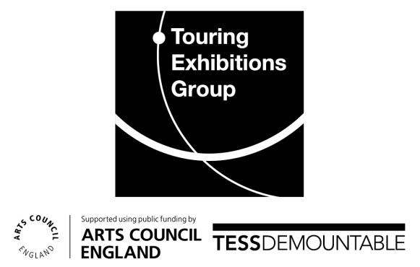

Preparing to Borrow Mentoring Programme
Mentee Application Form:
- Name:
- Email:
- Tel:
- Organisation:
- Role:
- Arts Council England (ACE) region:
- Has your organisation received Ready to Borrow or Small Scale Capital Grant monies to improve your exhibition space(s)?
Yes / No
- Please outline in no more than 400 words why you would like to work with a mentor to help you make an application to borrow:

- Please outline in no more than 200 words the types of object(s)/exhibition you would like to write a loan application for and provide a rough timescale for when you would like to submit the application and take on the loan.

- Please outline in no more the 200 words how you believe your participation in the Preparing to Borrow mentoring programme would benefit your organisation:

- Do you have your line manager’s support and permission to take part in the Preparing to Borrow mentoring programme?
Yes/No

